
2014|Student Guide



PUBLIC HEALTH

This publication was made possible in part through the support provided by the United States Agency for International Development (USAID). The opinions expressed herein are those of the author(s) and do not necessarily reflect the views of USAID or the US Government. USAID reserves a royalty-free nonexclusive and irrevocable right to reproduce, publish, or otherwise use, and to authorize others to use the work for Government purposes.

Module: Public Health


This module brings a One Health approach to public health by looking at the interface among human, animal and ecological health as students explore how to prevent disease and promote public health within groups of people, from small communities to entire countries. Students are introduced to critical public health topics in this module, including air quality, water quality/sanitation, food safety/security, epidemiology/biostatistics, maternal/child health and social science. The module includes discussions on public health and One Health policy and stakeholder involvement.

There are thirteen sessions in this module:
Module Agenda
60 Minutes | Introduction to Public Health
60 Minutes | Ecosystem Health, Climate Change and Public Health
120 Minutes | Animals and Public Health:  Human/Wildlife Interactions (Zoonoses)
180 Minutes | Animals and Public Health:  Human/Domestic Animal Interactions
150 Minutes | Foodborne Diseases, Food Safety and Food Production
60 Minutes | Water Quality, Sanitation and Waterborne Diseases
60 Minutes | Disease Monitoring and Surveillance:  Basic Epidemiological Terms/Disease Investigation
60–90 Minutes | Disease Monitoring and Surveillance:  Local and Global Disease Surveillance
240 Minutes | Community Health
120 Minutes | Policies and Programs
60 Minutes | Taking a One Health Approach to Public Health Policies and Programs
90 Minutes | Systems Thinking: Building Stakeholder Consensus using a One Health Approach to a Public Health Issue
60 Minutes | Learning Reflections and Evaluation

Module Competencies

Competency #1 |  |  | Learning Objectives to Develop Competency
Understand public health practice and its relationship to One Health. |  |  | Understand the breadth and scope of public health practice in a student’s country as related to One Health, including:  - Environment and public health.  - Animals, infectious disease and public health.  - Domestic animals and public health.  - Food safety and hygiene.  - Community health monitoring, disease surveillance, disease investigation and outbreak response.
 | Competency #2 |  | Learning Objectives to Develop Competency
 | Understand the interrelationships among government authorities, policymakers, industry, and researchers related to implementation of public health programs. |  | Explain how public health programs are developed and implemented for:  - Water  - Food – fruit and vegetables, livestock  - Wildlife  - Domestic animals  - Vermin, peri-urban wildlife
 | Competency #3 |  | Learning Objectives to Develop Competency
 | Analyze national or local public health policies. |  | Examine existing national and local public health policies and consider the following questions:  - Do policymakers and agencies responsible for public health use One Health approaches?  - Which do?  - Which do not?  - Is a One Health approach appropriate?  - Why has a One Health approach not been used to date?  - Are there impediments to using a One Health approach for this topic?
 | Competency #4 |  | Learning Objectives to Develop Competency
 | Using systems thinking to analyze/create a public health policy. |  | Use systems thinking to develop a new model for regional public health policies and regulations that would promote a One Health approach to public health issues:  - Who are the stakeholders?  - What are the push–pull factors in engaging stakeholders and getting their acceptance?

INTRODUCTION TO PUBLIC HEALTH

Learning Objective: |  | - Articulate how public health is a component of One Health
 | 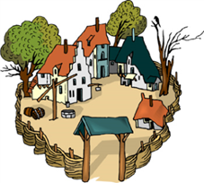

Overview of Key Terms and Concepts in Public Health and One Health
  Lecture | Public health is the practice of preventing disease and promoting good health within groups of people, from small communities to entire countries. American Public Health Association  The concept of One Health has been characterized using various approaches but all involve the convergence of health risks at the human-animal-ecosystem interface. One Health is about working inclusively across disciplines, professions, and sectors from the local to the global level, to improve the health of humans, animals, and the environment.  One Health Talk

Notes:
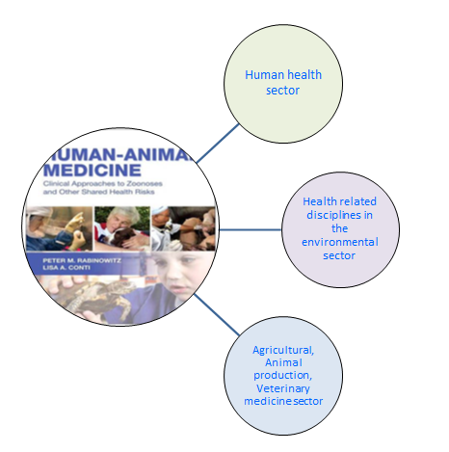

What Do You Think?
 | How does taking a One Health approach to public health strengthen a community’s ability to address complex health issues?

Notes:

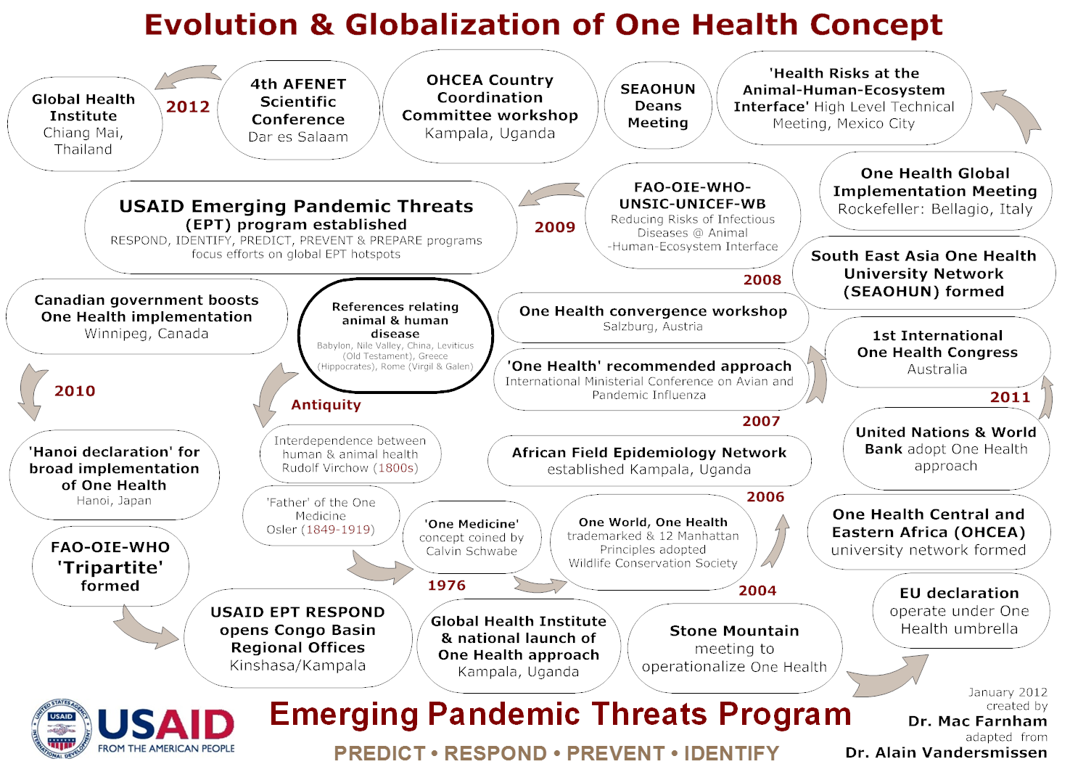
ECOSYSTEM HEALTH, CLIMATE CHANGE AND PUBLIC HEALTH

Learning Objective: | - Define the term ‘ecosystem’ and understand the importance of ecosystems with respect to human and animal health.  - Describe examples of ecological and social changes and the impact on global health.  - Explain why and how environmental changes (such as climate change) affect global health  .
Pre-Class Reading Assignment | - Patz, J.A., P. Daszak, G.M. Tabor, A.A. Aguirre, et al. “Unhealthy Landscapes: Policy Recommendations on Land Use Change and Infectious Disease Emergence.” Environ Health Perspect. 2004 Jul; 112(10): 1092К8.  - McMichael, A.J., R.E. Woodruff, and S. Hales. “Climate change and human health: risks and responses.” Lancet 2006 Mar 11; 367(9513): 859–69.
Overview of Key Terms and Concepts in Ecosystem Health
Lecture | An ecosystem is a community of living organisms (plants, animals and microbes) in conjunction with the nonliving components of their environment (things like air, water and mineral soil), interacting as a system. These biotic and abiotic components are regarded as linked together through nutrient cycles and energy flows.  Wikipedia (http://en.wikipedia.org/wiki/Ecosystem)

Notes:
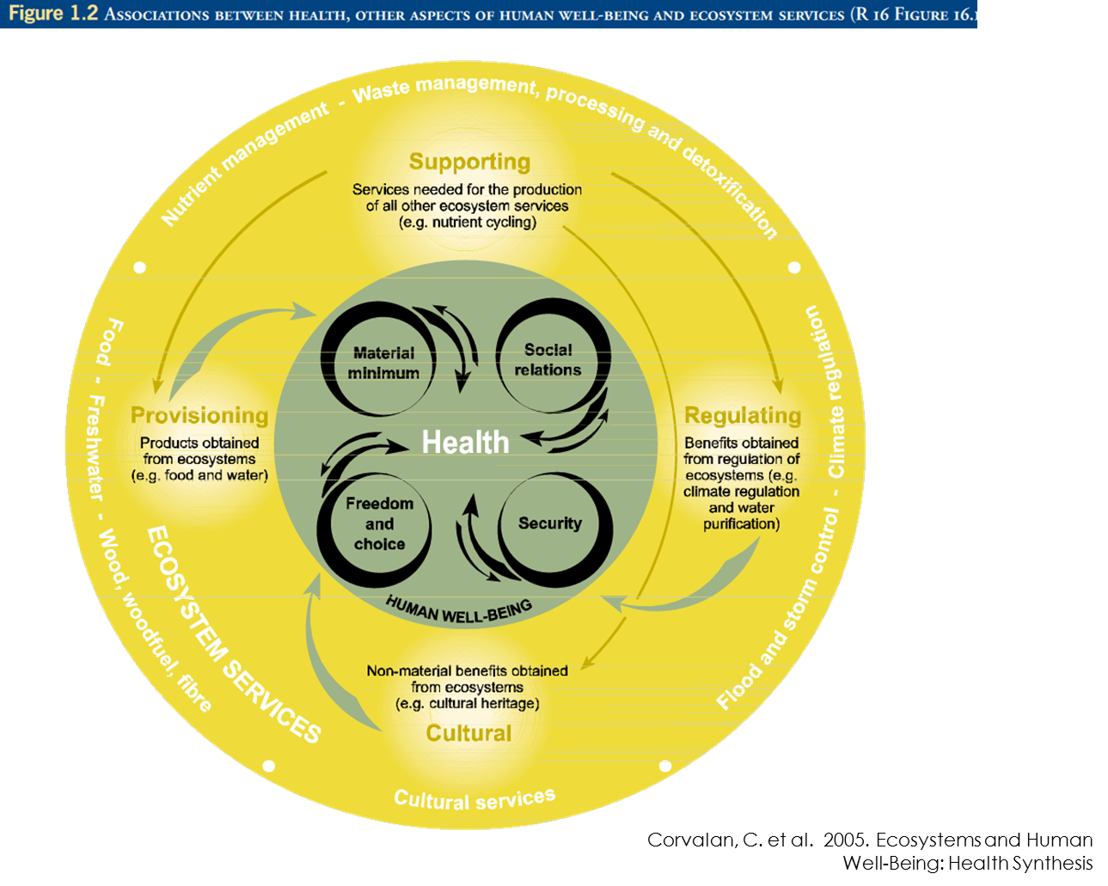
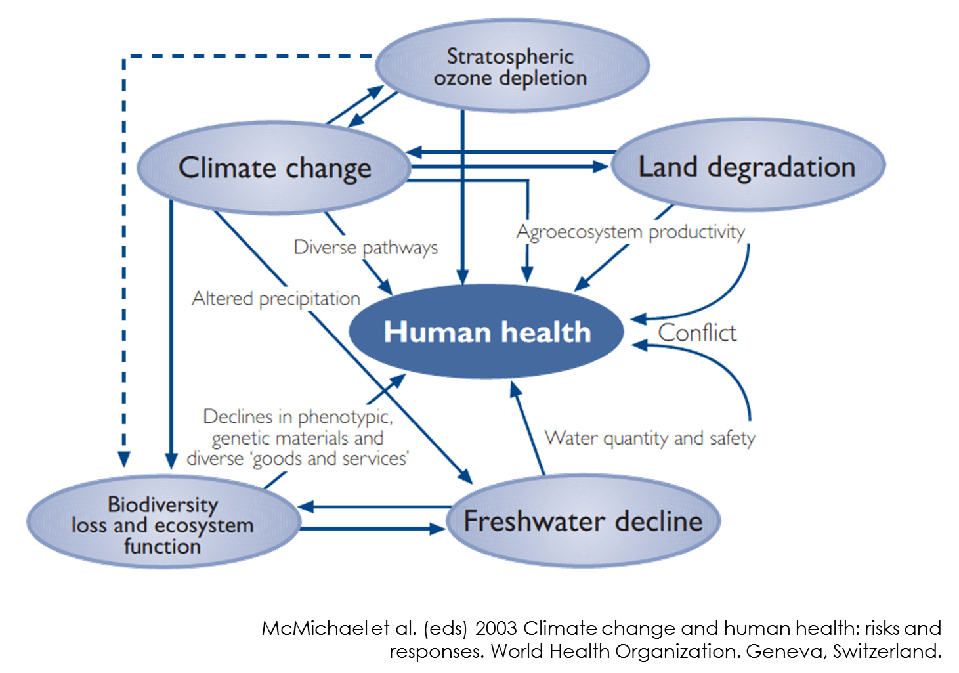
What Do You Think?
What is the impact of landscape change and climate change on public health? How can a One Health approach effectively address the impact of these changes on emerging and reemerging pandemic threats?

 |  | Notes:
ANIMALS AND PUBLIC HEALTH:
Human /Wildlife Interactions (Zoonoses)

Learning Objective: |  |  | - Define the terms ‘zoonoses’ and ‘emerging diseases.’  - Explain the importance of zoonoses in One Health and public health.  - Discuss the key reasons for disease emergence and reemergence.  - Provide examples of selected zoonoses pertinent to the region.
 | Wildlife and Public Health
Lecture | Zoonosis is an infectious disease that is transmitted between species from animals other than humans to humans or from humans to other animals.  - Vector: an organism that transmits a pathogen from reservoir to host  - Reservoir: a long-term host of a pathogen  - Fomite: an inanimate object that can transmit an infectious agent
Notes:
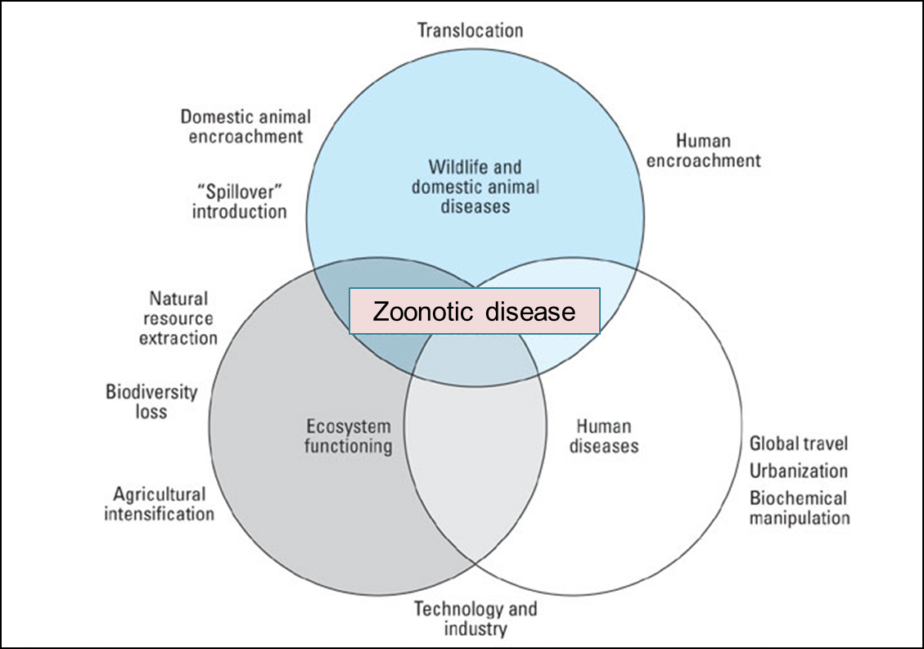

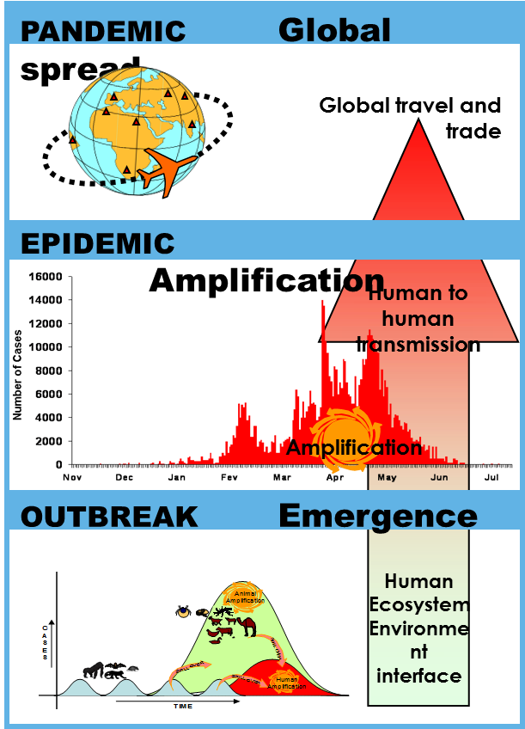

Bats, Rats, Primates and Me

 | 
  Taxa | Virus #1
  Bats | Nipah, SARS, Hendra
  Rats | Leptospirosis, Plague, Hantavirus
  Primates | Yellow fever

Prepare a 10-minute presentation that teaches the class about your assigned animal—a bat, a rat or a primate—explaining:
- Common zoonotic viruses found in the taxonomic group
- Transmission routes
- Health effects in humans

Notes:

Class presentation notes:

What do you think?
- What did all the diseases have in common?
- What made each unique?
- How could adopting a One Health approach help control an emerging or reemerging pandemic threat of the diseases?

ANIMALS AND PUBLIC HEALTH
Human/Domestic Animal Interactions

Learning Objective: | - Discuss how interactions between humans and domestic animals can affect both human and animal health.
Pre-Class Assignment: | Read Article - ”The origin of human pathogens: evaluating the role of agriculture and domestic animals in the evolution of human disease” (Jessica M. C. Pearce-Duvet)  Come prepared to discuss:  - How much evidence is there that human pathogens originated from humans?  - What role does the animal domestication play in pathogen transmission to humans?  - Do you agree with the conclusion by the author of this paper? Why or why not?
The Origin of Human Pathogens
 | With a small group of your fellow students, discuss the article sharing your ideas on the pre-work questions.

Photovoice

Photovoice is a method mostly used in the field of community development, public health and education, which combines photography with grassroots social action. Participants are asked to represent their community or point of view by taking photographs, discussing them together, developing narratives to go with their photos, and conducting outreach or other action.

Notes:
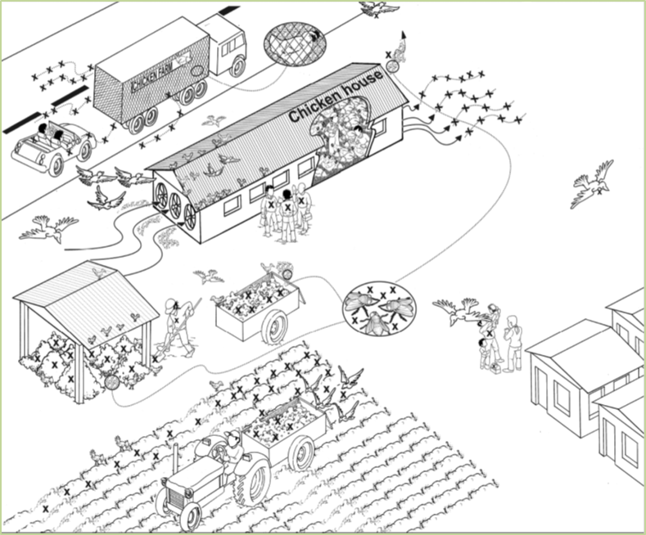
Source: Concentrated Animal Feeding Operation, drawing by Salvador Saenz
The drawing is of a concentrated animal feeding operation. What potential pathways for exposure to and transfer of pathogens do you see in this picture?
Observing Human/Domestic Animal Interactions
  PowerPoint | 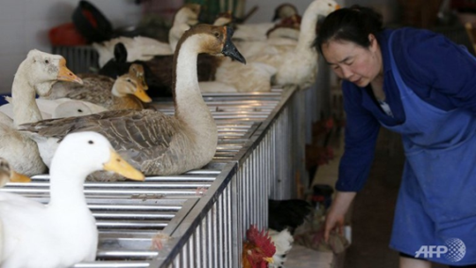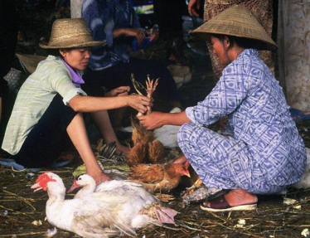

Notes:

Using the internet, with a small group of your classmates, create a Photovoice presentation illustrating:
- Diseases that have been transmitted from animals (pets and livestock) to humans throughout history and identify which diseases are sporadic or have become pandemics and/or epidemics.
- How these diseases are commonly transmitted.
- Type of transmission would probably result in large epidemic or even pandemic. What are the characteristics of this type of transmission.
- Potential ways to prevent transmission.

Notes:

What do you think?
- From the presentations, what modifications—add, change or remove—would you make to your presentation?”
- How does understanding human/domestic animal interaction strengthen an understanding of human health?
Notes:
Notes:

FOODBORNE DISEASES, FOOD SAFETY AND FOOD PRODUCTION

Learning Objective: | - Identify causative agents, sources, habitat and risk factors and disease burden of food borne illness.  - Describe good hygienic practices and food safety measures.  - Define hazard and critical control point in the food production.
Foodborne Diseases and Food Safety: From Farm to Fork
Lecturette | The lecture focuses on:  - Foodborne illness, common causative disease agents; sources and habitat and risk factors for foodborne illness.  - Food production chain and factors that are associated with microbial growth.  - Details on good hygienic practices and Hazard Analysis and Critical Control Point (HACCP) from purchase to table.


Notes:
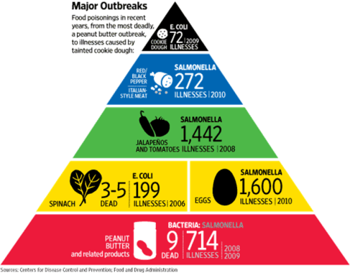
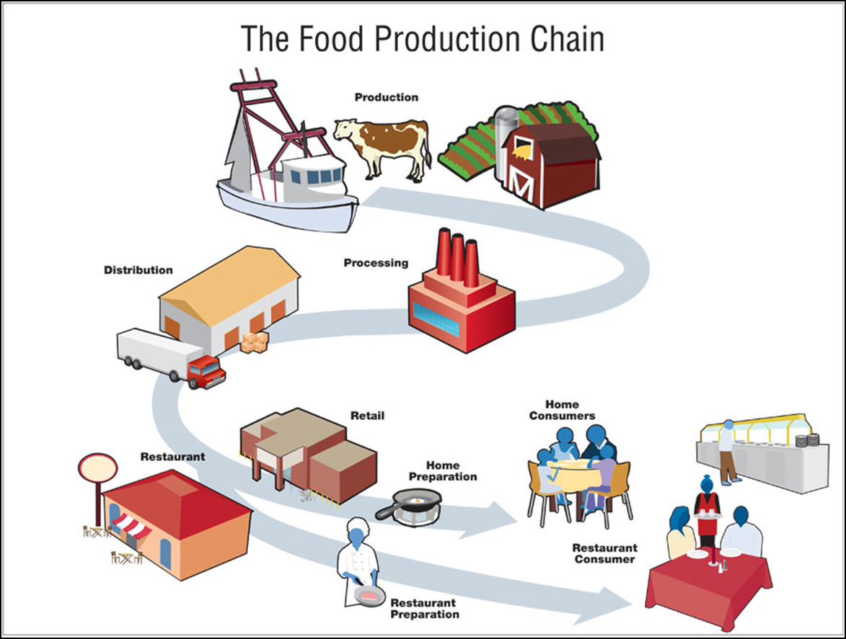

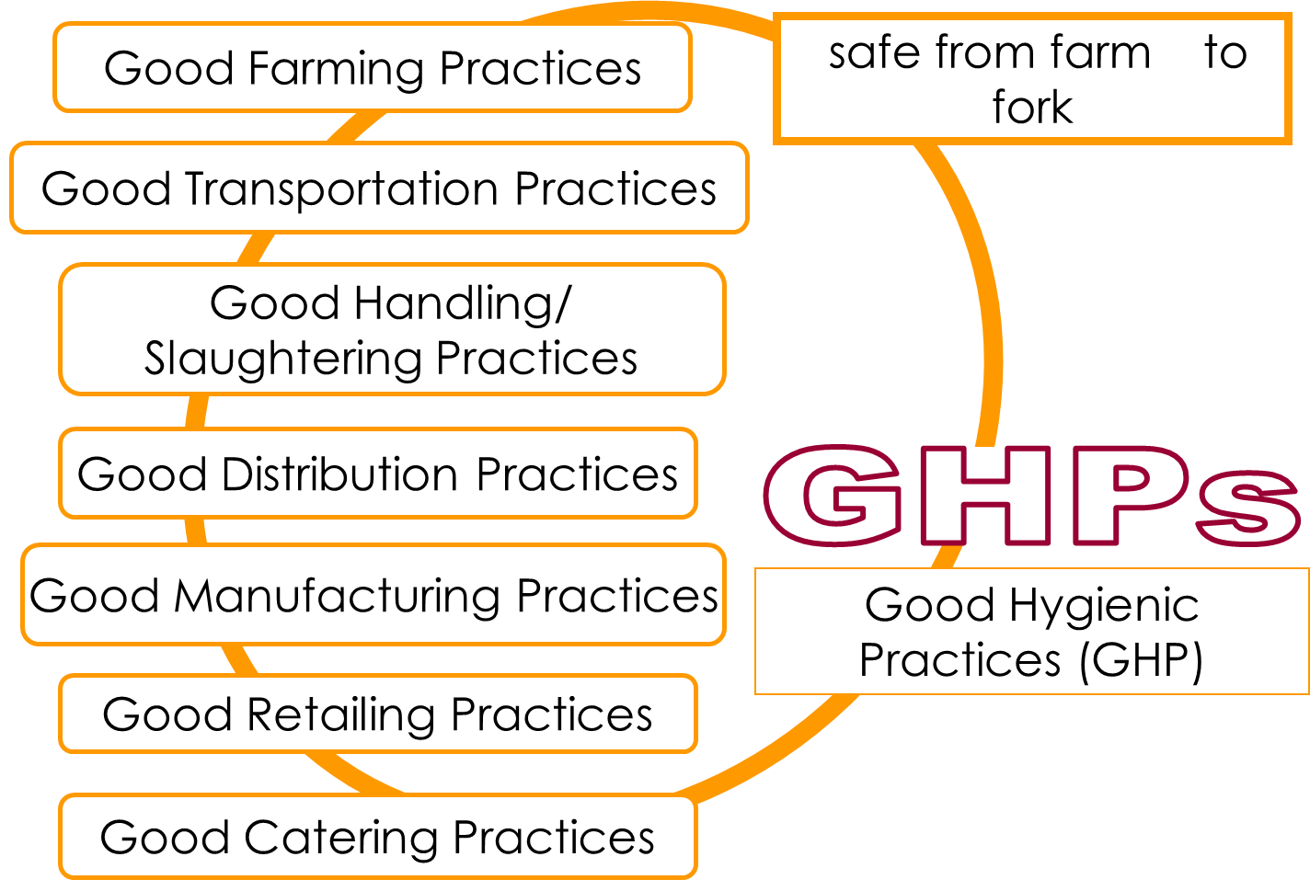
Assessing Food Safety
Brainstorm how you would assess the hygiene and sanitation of one of the industries listed below:
Your instructor will assign you an industry.
- Slaughterhouses (chicken, cattle, sheep, pig)
- Food industry (milk, meat, egg)
- Market (many foodstuffs)

Prepare a checklist on a flipchart to share your ideas with the class.

Notes:

After completing the checklists – answer the following questions:
- How can good hygiene and sanitation in the food industry positively impact human health?
- How is HACCP related to public health?
- What zoonotic diseases are of animal origin and can be transmitted through foods?
- Should hygiene and sanitation be regularly monitored, or is a single inspection or evaluation adequate?

Notes:

Field Trip
Prepare for a field trip to either a slaughterhouse, food industry or food market. Use the checklists on
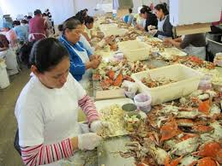
the following pages to assess the facility.

www.washingtonpost.com
Food Safety and Sanitation
Checklist for Good Manufacturing Practices (GMPs): Building and Facilities

Criteria | Good | Needs Work
Is the area around your firm clear of litter, weeds, grass and brush?
Is there any standing water on your grounds (which also attract pests)?
Are floors, wall, ceiling, windows and screens properly maintained and cleaned? There should be no flaking paint anywhere above the production area
Do production area doors and windows to the outside have fine mesh screens to keep out insect? If not are they tightly sealed?
Will a pencil pass under the door?
Have holes and cracks been filled so as not to provide hiding places or entry points for pests?
Is there any evidence of the presence of domestic animals, such as cats or dogs?
Are restrooms cleaned regularly?
Are there hand-washing facilities for workers and for visitors that are furnished with soap and paper or air hand dryers?
Are there any leaks in the roof, skylights, windows, screens or overhead piping?
Are the overhead lights covered with shields to prevent contamination of products by broken glass in case the lamps break/burst?
Total Checked:

Notes:
Checklist for GMPs: Production and Process Control

Criteria | Good | Needs Work
Are products and stocks stored on the first-in/first-out basis to reduce the possibility of contamination through spoilage?
Are all incoming products dated to ensure a proper rotation of stocks and for internal tracking purposes?
Are items overstocked? This increases the chances of spoilage and contamination?
Are incoming vehicles inspected?
Are dusty, faded or discolored containers checked regularly?
Are all products spoiled by damage, insects, rodents or other causes stored in a designated “ quarantine area” to prevent their contact with safe products?
Are such quarantined items disposed of quickly to prevent the development of pest breeding places?
Are incoming materials inspected so that damaged or contaminated items can be rejected?
Are unused materials properly resealed to prevent contamination?
Are materials stored in a safe manner? Food-related items should not be stored with non-food related items. Materials should be stacked so that vents and blowers are not blocked. Stacks of materials should be orderly for safety purposes
Do you have an effective recall procedure in place?
Total Checked:

Notes:

Checklist for GMPs: Equipment

Criteria | Good | Needs Work
Is all equipment that comes in contact with food cleaned and sanitized as often as necessary to prevent contamination of the product? Cleaning schedules appropriate for each piece of equipment should be followed.
Is the equipment designed or otherwise suitable, for use in food plants? (For example: equipment for handling or processing foods cannot contain polychlorinated biphenyls [PCBs], which are very toxic; this does not apply to electrical transformers and condensers containing PCBs in sealed containers.)
Is there a build-up of food or other material on the equipment? This can serve as a breeding place for insects, fungus/mold, and/or bacteria
Is there any build-up or seepage of cleaning solvents or lubricants on your equipment, which can contaminate foods? All repairs on equipment should be of a permanent nature (e.g., no bobby pins in place of cotter pins), as temporary repair parts can break or rupture and get in the food product.
Is the equipment hard to disassemble for clean-up and inspection? The more difficult it is, the less inclined you or an employee will be to clean it
Is there a lot of “dead space” in or around the machinery where food and other debris can collect as a nest for insects and bacteria?
Can the surface of the equipment be sanitized?
Total Checked:

Notes:

Checklist for GMPs: Personal Hygiene

Criteria | Good | Needs Work
Are the employees well-trained in what they do? You can avoid many problems by making sure that your employees clearly understand their function
In handling food products, do your employees wear the proper hair covering, breast covering, disposable gloves and clean uniform?
Are your employees wearing jewelry, rings, watches, fingernail polish or bandages?
Do your employees have any illness, infections or injuries (i.e. boils, cuts) that could contaminate food in the production area?
Do your employees wash and sanitize their hands after each visit to the toilet?
Do your employees maintain clean personal habits?
Is the traffic within your plant controlled to prevent contamination of the production area?
Do visitors wear proper outfits and helmets?
Have your employees been told the reasons why they should regularly observe and practice the above precautions?
Have your employees had GMP training?
Total Checked:

Notes:

Checklist for GMPs: Sanitation Operations - Pest Control

Criteria | Good | Needs Work
Do you have professional pest control services?
Do you check regularly on what the pest control operator is doing?
Do you have documentation on what chemicals are being used?
Are mites, weevils or roaches apparent in the plant? There should be no evidence of their presence.
Do you have enough bait stations?
Are you using fumigation safety?
Are the pest control logs and documentation readily available?
Are pesticides or application equipment stored safely?
Are products stored on a pallet and at least 18 inches away from the walls?
Is your facility well maintained?
Total Checked:

Notes:

Checklist for GMPs: Sanitation Facilities and Control

Criteria | Good | Needs Work
Are trash, debris and clutter picked up, both inside and outside the plant, so as not to provide hiding places for pests?
Do all sanitation chemicals used in the plant follow the U.S. Department of Agriculture/Food and Drug Administration or ther standard(s)?
Do employees eat, drink and use tobacco products only in designated areas, and not in production area or were house?
Is the food spilled or uneaten by employees cleaned up quickly so as not to attract pests or bacteria?
Has old rodent excreta been cleaned up so you can spot any new activity?
Is the garbage quickly removed and dumped in appropriate bins? It should not sit around your facilities to attract pests and develop odors?
Is the garbage kept covered? An open garbage pile is an excellent breeding ground for insects and rodents.
Is the water used in your firm from an approved source (either municipal supply or tested private source)?
Have you made sure there are no hoses left dangling in sinks or on the ground? Loss of pressure can cause a back flow that will contaminate your water supply?
Do your facilities have back flow and vacuum breaker valves to prevent contamination of your water supply?
Is there standing water around your firm (in particular, in the production area, warehouse and pack-off area)?
Total Checked:

Notes:
Checklist for GMPs: Sanitary Procedures for Cleaning and Sanitizing

Criteria | Good | Need Work
Is the equipment disassembled?
Is product debris removed?
Is the equipment sanitized with an approved sanitizer and rinsed with potable water if required?
Are facilities cleaned with an approved cleaner, according to the manufacturers’ directions/instructions?
Are facilities rinsed with potable water, as necessary?
Do the employees clean hands, arms, gloves, aprons, boots, etc., as often as necessary during the handling procedures?
Do the employees clean and then sanitize any equipment as often as necessary during handling procedures to prevent contamination of food or packaging materials?
Total Checked:

Notes:
Checklist for GMPs: Hazard Analysis and Hazard Plans

Criteria | Good | Needs Work
Does the hazard analysis include food safety hazards?
Does the hazard analysis include a flow chart that describes (diagrams) the steps of each process and product flow in the establishment?
Does the hazard analysis identify the intended use or consumers of finished product (s)?
Does the Hazard Analysis and Critical Control Point (HACCP) plan list the food safety hazard(s) identified in the hazard analysis?
Does the HACCP plan list critical control points (CCPs) to each food safety hazard?
Does the HACCP plan list critical limits to be met at each CCP?
Does the HACCP plan list the procedures to be used to monitor each CCP and the frequency with which these procedures will be performed?
Does the HACCP plan identify the corrective action to be followed in response to a deviation from a critical limit at a CCP?
Does the HACCP plan’s record keeping system document the monitoring of CCPs and/or include records with the actual values and observations?
Total Checked:

Notes:
Field Trip Debrief
Share your observations about where you saw good hygiene and sanitation practices and areas for improvement and what improvements should be put in place.

What do you think?
- What are the impacts of good hygiene and sanitation in food industry on human health?
- How do these relate to the hazard analysis and critical control point and public health?
- What zoonotic diseases can be transmitted through foods from animal origin?

Notes:

WATER QUALITY, SANITATION AND WATERBORNE DISEASE
Learning Objective: |  |  | - Describe the importance of water quality and sanitation related to human health.  - Describe water sources, uses, infrastructure, and threats to water quality.  - Explain the global status of drinking water and sanitation.  - Discuss the relationship between water and health.  - Give examples of waterborne diseases and their associated pathogens.
Water and Health

Lecture | 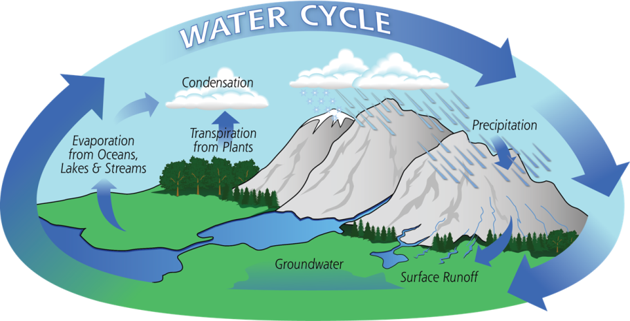  Topics include:  - Water sources and uses  - Water cycle and why water has a role in health  - Water as a human right  - Drinking water – global perspective  - Sanitation – global perspective  - Water infrastructure and threats to water quality  - Threats to water quality  - Waterborne diseases and pathogens
Notes:

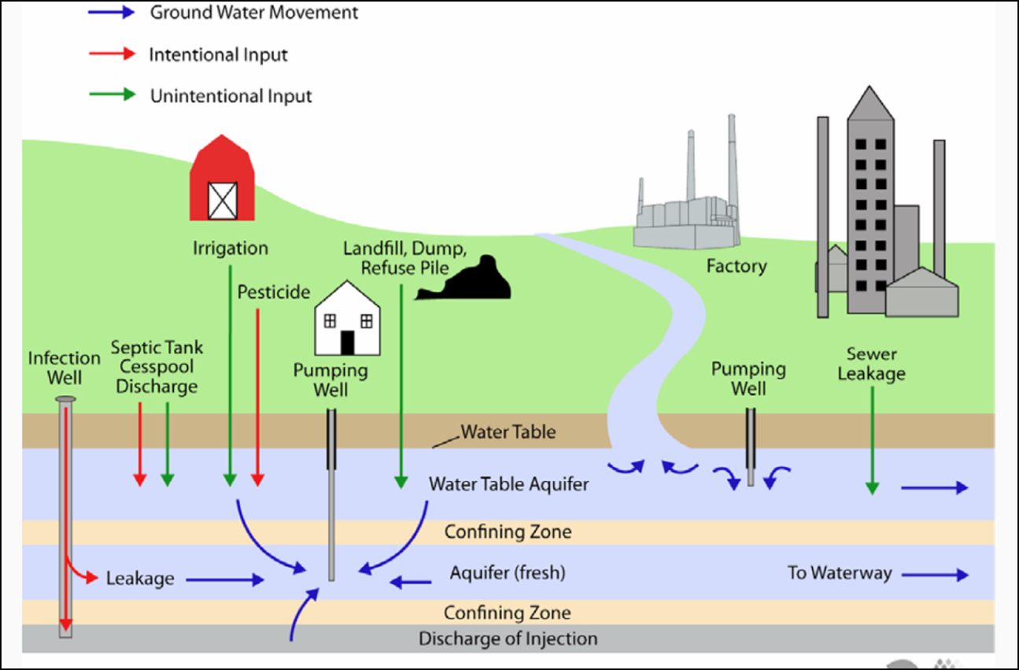

Notes:

Class Exercise - As Assigned by the Instructor

Notes:

DISEASE MONITORING AND SURVEILLANCE:
Basic Epidemiological Terms/Disease Investigation

 | Learning Objective: | - Describe the principles of basic epidemiology and discuss its application in disease surveillance and monitoring.
Epidemiological Definitions
Lecture | - Epidemiology: The study of how disease is distributed in populations and of the factors that influence or determine this distribution.  - Endemic: The habitual presence of a disease within a given geographic area.  - Epidemic: The occurrence in a community or region of illnesses or similar nature, clearly in excess of “normal” or “expected” rates, and derived from a common or a propagated source.  - Incidence: The number of new cases of a disease that occur during a specific period of time in a population at risk for developing the disease.  - Prevalence. The number of affected persons present in the population at a specific time divided by the number of persons in the population at that time.  - Passive Surveillance: Routine reporting of cases of disease.  - Notifiable Diseases: Every country has a list of diseases that must be reported to health departments.  - Active Surveillance: Proactively seeking out cases of a specific disease in an area; this could be through door-to-door surveys or by contacting health care providers or health facilities.

Notes:

The Contagious Classroom
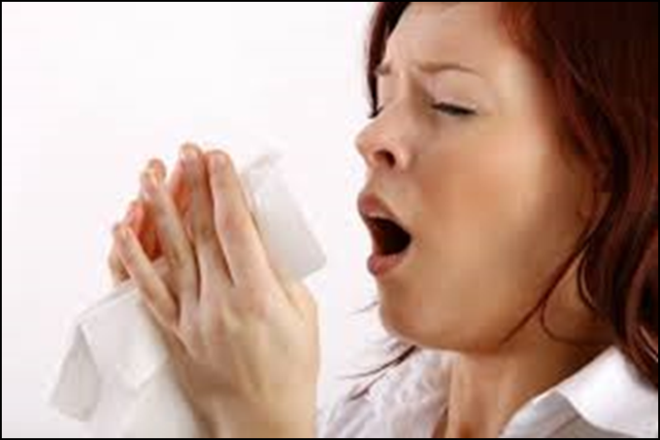
What do you think?
Reflections on the Contagious Classroom
Notes:
DISEASE MONITORING AND SURVEILLANCE:
Local and Global Disease Surveillance

 | Learning Objective: | Be able to critically analyze available disease surveillance information (local and global) and resources to determine the keys issues and stakeholders involved in disease trends, and outbreaks or epidemics.
Pre-work
 | For each of the websites listed below, consider the following questions:  - What is its purpose?  - What is the source of information they use?  - Do you think that it would be a reliable source for determining if an outbreak has occurred?  - When would someone use the website?  In addition, consider the following questions  - Is there a resource that you can monitor to know what is going on in an area that you care about?  - Can you find the incidence and prevalence data for your area?  Disease Surveillance Websites  - World Health Organization (WHO) – Global Health Observatory: http://www.who.int/gho/publications/world_health_statistics/2013/en//  - U.S. Centers for Disease Control and Prevention (CDC), Morbidity and Mortality Weekly Report: http://www.cdc.gov/mmwr/  - Promed: http://www.promedmail.org/  - Health Map: http://healthmap.org/en/  - Global alert and response: http://www.who.int/csr/en/  - Google flu: http://www.google.org/flutrends/about/how.html  - Mekong Basin Disease Surveillance: http://www.mbdsoffice.com/index_vn.php
Notes:

Using ProMed to Reconstruct an Outbreak
Small Group Activity | Using ProMed, reconstruct the 1998 Nipah virus outbreak in Malaysia.  Note: Your instructor will assign your group a timeframe to study.

Month | What is happening with animal health and who are the stakeholders? | What is happening with human health and who are the stakeholders? | Are environmental factors being considered? If yes, how so? | What is going wrong? Why? | What is going right?  Why?
November 1998
December 1998
January 1999
February 1999
March 1999
April 1999
May 1999
June 1999
July 1999
August 1999
September 1999

COMMUNITY HEALTH

LECTO
Learning Objective: | - Examine community health from a One Health perspective.

Preparation for Observing Your Community
 | The overall questions that you want to answer when observing your community are:  - What is the relationship of the on-campus community with the environment?  - What is the relationship of the on-campus community with wildlife and domestic animals?
Develop a checklist to evaluate how and where the community is vulnerable to exposure from environmental or zoonotic pathogens. To create your checklist, you may want to use some of the questions from the sample community health checklist below.

Community Health - Sample Checklist

NUISANCE ANIMAL CONTROL/MANAGEMENT – Rodents and other “pest” wildlife can carry zoonotic disease and are attracted to food storage, agriculture, and waste areas. | Yes | No | N/A | Notes
- Do on-site features exist that could attract wildlife (food storage, food waste storage, waste accumulation, open water sources, agricultural production [specifically, grain or fruit production], livestock, pets)?
- Are pest control/management measures in place to minimize interaction with wildlife or to prevent wildlife from accessing the facilities?
  - Do they address:
    - Food storage protection provisions
    - Food waste storage and disposal
    - Housing protection
    - Safe removal of animal droppings and nests
    - Controls at disposal areas
    - Food crop protection
    - Livestock protection
- Are specific measures in place to address the following:
  - Rodents
  - Bats
  - Non-human primates
  - Other species of concern

ON-SITE INFRASTRUCTURE  Maintaining a healthy student body and reducing potential exposure contact with animals or their excreta reduces the risk of zoonotic disease transmission. | Yes | No | N/A | Notes
ON-SITE HOUSING
Pests can reside in housing. In addition, inadequate space, food storage, sanitation, etc. can amplify any disease incident
- Are student housed on-site?
  - Are there adequate beds for the number of students?
  - Are washing facilities adequate?
  - Are sanitation facilities adequate?
  - Are waste disposal facilities sufficient?
FOOD
Food can be contaminated by pest animals at any step of the food acquisition to consumption process. In addition, certain meats may be contaminated by disease
- Are students fed on campus?
  - Is a Hazard Analysis Critical Control Point (HACCP) system or comparable food safety program in place?
(See: http://www.fda.gov/food/guidanceregulation/haccp/ucm2006800.htm)
  - Are WHO’s Five Keys to Safer Food implemented? (See: http://www.who.int/foodsafety/consumer/5keys/en/)
  - Is food stored in rodent proof locations or containers?
  - Are measures in place to ensure that meat is bought only from vendors who do not sell bushmeat?
  - Are measures in place to inspect fruits and vegetables to prevent serving food that has been contaminated by animals (presence of feces, bite marks)
WATER
Water can attract wildlife and become contaminated. It can also act as habitat for vectors
- Is the site checked regularly for standing/stagnant water, structures, or debris that can act as insect breeding areas?
- Do workers have access to an adequate and convenient supply of free potable water, and is it always available to workers?
- Does drinking water meet national/local or WHO drinking water standards?
  - Is drinking water quality monitored or treated regularly?
- Are water storage tanks that are used for drinking water covered to prevent the water from becoming polluted or contaminated?

SOLID WASTE  Solid waste, sewage and food waste can attract pests | Yes | No | N/A | Notes
- Are wastewater, sewage, food and any other waste materials disposed of according to local or World Bank standards?
- Are containers for trash collection provided and emptied on a regular basis?
- Is pest/vector control and disinfection conducted throughout the living facilities?

TERRESTRIAL BIOLOGICAL RESOURCES  Habitat disturbance and degradation can alter wildlife ecology and may lead to changes in wildlife disease dynamics. Changes in biodiversity may impact the potential for zoonotic disease transmission. | Yes | No | N/A | Notes
- Loss of vegetation/habitat and creation of edge effect
  - Are measures in place to minimize additional loss of wildlife habitat/fragmentation?
  - Are measures in place to re-vegetate areas disturbed by construction or maintenance using native vegetation?
- Are plans in place to manage natural vegetation in areas adjacent to cleared areas/the project site?
- Biodiversity Monitoring
  - Are measures in place to minimize wildlife disturbance (e.g. migration)?
  - Is a biodiversity monitoring plan in place?
    - If yes, has it been integrated with operations to ensure the appropriate best management practices (BMPs) are in place?
  - Are measures in place to address biodiversity loss?

LOCAL RELATIONSHIP WITH WILDLIFE | Yes | No | N/A | Notes
- Are local wildlife possible carriers of zoonotic diseases?
- Is bushmeat^{(a)} used as a source of protein and what species are hunted?

(a) The definition of bushmeat is variable given a region or country. In this context, ‘bushmeat’ is used to mean meats originating from non-domesticated animals.
- How are bushmeat/domestic animals harvested, butchered, transported, and prepared?
- How do locals interact with rodents, bats, and non-human primates?
- What potential exposure pathways exist between these animals and humans in the area?

*Note: Most of the questions in the Onsite Infrastructure are taken or adapted from International Finance Corporation (IFC) and the European Bank for Reconstruction and Development (EBRD). n.d. Workers' Accommodation: Processes and Standards - A guidance note by IFC and the EBRD
Observations - Your Checklist

 | Yes | No | N/A | Notes
 | Yes | No | N/A | Notes

Additional Observations:

What do you think?

- How did other’s observations compare with yours?
- What are the three top issues that the campus needs to address to become more “One Healthy”? As a class, come to consensus on the top three issues?
- What would be your recommendations to address these issues?
Notes:

POLICIES AND PROGRAMS

LECTO
Learning Objective: | - Understand the relationships among government ministries, local organization, policies and programs.

National and Local Policies and Programs
Using the table on the following pages:
- Identify the different governmental organizations in your country that have policies on one of the following topics.
  - Water consumption/use
  - Grains/fruits/vegetables
  - Cows/pig/poultry
  - Cat/dogs/exotic animals
  - Bats/primates
  - Rodents
- Provide an example of a program and policy for each category.
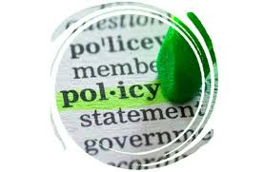
Notes:

Resource | Topic | Ministry | Policy | Implementing Agency | Program | Stakeholders

Water

Sanitation
Resource | Topic | Ministry | Policy | Implementing Agency | Program | Stakeholders

Grains, Fruits, Vegetables
Resource | Topic | Ministry | Policy | Implementing Agency | Program | Stakeholders

Cows, Pigs and Poultry
Resource | Topic | Ministry | Policy | Implementing Agency | Program | Stakeholders

Cats, Dogs and Exotic Animals
Resource | Topic | Ministry | Policy | Implementing Agency | Program | Stakeholders

Bats and Primates
Resource | Topic | Ministry | Policy | Implementing Agency | Program | Stakeholders

Rodens

Notes:

SYSTEMS THINKING
Building Stakeholder Consensus Using a One Health Approach to a Public Health Issue

LECTO
Learning Objective: | - Apply systems thinking to analyze a public health issue using a One Health approach.

Preparing for Simulation
  and | Check off the role you were assigned:  - Environmental Non-Governmental Organization - Bat Conservation International, World Wildlife Fund  - Ministry of Health  - Ministry of Commerce and Tourism  - Ministry of Agriculture/ Fruit Crop Growers  - Ministry of Natural Resources  - Indigenous Population/Guano Harvesters  - University Department of Wildlife/National Research Center  - Other
Directions:
- For the next 15 minutes, individually prepare:
  - Read the scenario below
  - Think about what your position on bat conservation/management/control.
  - In an ideal world, what would you like the policy to be? On what issues are you willing to compromise? On what issues are you not willing to compromise on.

After individual reflection, spend 15 minutes in stakeholder groups planning how the groups will proceed in the scenario.

Scenario: Developing a Policy on Bats
Atangua is an island nation that is located 20 miles offshore of Malindo. It is known for its natural beauty because it is covered with rainforests and encircled by mangroves. It has several indigenous groups that subsist on forest and sea products. There are two urban centers that are growing. Industries on the island include tourism, fisheries, flower production, mango production and guano mining. A developer is proposing to build a high-end luxury resort within the rainforest.
Recently, as a result of fires in the tropical rainforest, some bats have begun to eat mangos in the mango orchards. Angry farmers have begun shooting at the bats to discourage them from eating the mangos. Bats are protected species and only indigenous populations are allowed to hunt them for rituals and for eating. Bats play an important role in pollinating and seed dispersal for rainforest trees. Among the indigenous population, fruit bats are considered sacred. They also harvest guano as a source of income.
An outbreak of Nipah has occurred on the mainland among people who harvest date palm sap. Date palm sap is consumed widely among the population of Atangua.
The tourism bureau of the country is afraid that the fear of Nipah virus will discourage tourists from coming to the island. The resort developer is threatening not to build the resort unless bats are removed from a 10–square-mile radius from the resort area.
The Governor has assembled a group of committees to address the bat conservation management issue with the mandate that, by the end of the session, they must have a framework for the bat policy.
Each person must assume a role and advocate on his/her behalf.
The Governor will hear the positions of each group for 3 minutes. The facilitator will write on flipcharts the position of each group and their proposal. The facilitator will have groups with opposing policies or views to meet, to arrive at a consensus, and to cooperatively develop a bat policy that will be implemented on the island.

Notes:
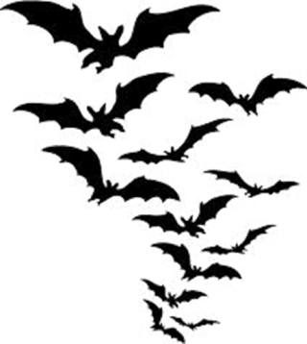

What do you think?
Large Group Exercise |  | - What happened during the meeting?  - What was the result?  - Are you satisfied with the outcome?  - If “YES,” why? If “NO,” why not?  - Were you able to successfully reach consensus and create a One Health policy?  - What do you feel are the strengths of the policy?  - What are areas you feel still need to be strengthened?
 | Notes:

LEARNING REFLECTIONS AND EVALUATION

Learning Objective:
- Reflect on your learning in the Public Health module.
- Provide feedback on the strengths of the module and which areas in the module could be improved.

Self-Evaluation
  Individual Learning Assessment
  How would you rate your level—from understanding to  being able to apply to being able to evaluate and create—for the Public Health module: | Understand | Apply | Evaluate/  Create
  Understand public health practice and its relationship to One Health.
  Understand the interrelationships among government authorities, policymakers, industry and researchers to implement public health programs.
  Analyze national or local public health policies.
  Use system’s thinking to analyze/create a public health policy.
Write down two or three things that you learned from the session. Think about:
- What was new or surprising to you?
- What have you changed your mind about?
- What are you still unsure about?
- What was interesting to you/what would you like to study in more detail?
- Are there new behaviors that you will try based on this class?
- What topics from the class will you share with others outside the class?

Notes:

Sharing the Learning
Small Group  Discussion | In a small group, share:  - Your key learnings from the module.  - How you will apply the concepts, knowledge, skills you gained from the module.
Notes:

RESOURCES FOR STUDENTS

Homework - Available in Resource Folder
“Water for Health: Taking Charge,” WHO
“Water Quality and Human Health Strategy: 2013–2020,” WHO
Dufour, Al, Bartram, Jamie, Bos, Robert and Gannon, Victor, “Animal Waste, Water Quality and Human Health,” WHO, EPA, IWA.
McMichael et al. (eds) 2006 Climate change and human health: risks and responses.
NIPAH Reports, ProMed

Patz et al. 2004. Unhealthy Landscapes: Policy Recommendations on Land Use Change and Infectious Disease Emergence. Environmental Health Perspectives: VOLUME 112, NUMBER 10, July 2004.
Pearce-Duvet, Jessica M. C., “The origin of human pathogens: evaluating the role of agriculture and domestic animals in the evolution of human disease,” Biology Review, 81, pp. 369-382 (2006).

Disease Fact Sheets - Pro Med
- Hanta
- Hendra and Nipah
- Leptospriosis
- Plague
- SARs
- Yellow Fever

References Available in the Resource Folder

“Contributing to One World, One Health: A Strategic Framework for Reducing Risks of Infectious Diseases at the Animal-Human-Ecosystem Interface,” FAO, OIE, WHO (2008).

“The Ecosystems and human well-being: health synthesis,” WHO (2005).

“The Emergency of Zoonotic Diseases: Understanding the Impact of Animal and Human Health,” Board on Global Health, Institute of Medicine (2003).

“Water Quality for Ecosystem and Human Health,” Gems Water, UNEP, ERCE, UNESCO, Water and Research Management.

Bass, Aviram, R. M., and Parker K, “Extracting hope for bushmeat: case studies of oil, gas, mining and logging industries efforts for improved wildlife management,” Report for Bushmeat Crisis Task Force (2002).

Brander, Luke M., Wagtendonk, Alfred J., Hussain, Salman S. and McVitte, Alistair, “Ecosystems service values for mangroves in Southeast Asia: A meta-analysis and value transfer application,” Ecosystem Services (2012).

Calisher, Charles H., Childs, James E., Field, Hume E., Holmes, Kathryn, V. and Schoutz, Tony, “Bats: Important Reservoirs Hosts of Emerging Viruses,” Microbe, Volume 3, Number 11 (2008).

Graham, Jay, Leibler,Jessica, Price, Lance, Otte, Joachim, Pfeiffer, Dirk, Tiennsin, T., and Silbergeld, Ellent, “The animal-human interact and infectious disease in industrial food animal production: rethinking biosecurity and biocontainment,” Public Health Reports, Volume 123 (2008).

Leibler, Jessica, Otte, Joachim, Roland-Holst, David, Pfeiffer, Dirk, Magalhaes, Richardo Soares, Rushton, Jonathan, Graham, jay P., and Silbergeld, Ellen, “Industrial food animal production and global health risks: exploring the ecosystems and economics of Avian influenza,” EcoHealth, (2009)

Morel, Alexandra, “Ecosystem services of Southeast Asia: Major Threats and Opportunities,” Global Canopy Programme (2007).

Otte, Joachim, Pfeiffer, Dirk, Roland-Hoist, “Avian influenza, public health and smallholder livelihoods in the greater Mekong sub-region,” UKAID.

