
2014|Student Guide



Epidemiology and Risk Analysis

This publication was made possible in part through the support provided by the United States Agency for International Development. The opinions expressed herein are those of the author(s) and do not necessarily reflect the views of the US Agency for International Development or the US Government. USAID reserves a royalty-free nonexclusive and irrevocable right to reproduce, publish, or otherwise use, and to authorize others to use the work for Government purposes.

Module: Epidemiology and Risk Analysis

Module Overview


Epidemiology, epizootiology and population health are all terms describing the study of health and disease in populations, as distinct from individuals. Risk analysis is a systematic approach to evaluating both the likelihood of occurrence and the magnitude of impact if a particular adverse event occurs, and taking steps to mitigate that risk and communicate with relevant stakeholders and populations. Epidemiology and risk analysis are both important to the practice of the One Health approach, and professional health science programs incorporate these topics to some degree in their curricula. Recognizing that a One Health approach is broad and includes many disciplines distinct from health sciences (such as economics, social sciences, law and policy and many others), this module is designed to introduce those with little or no background in epidemiology to the history, concepts, theories, terminology and practice of epidemiology to improve their ability to collaborate with epidemiologists. Key outcomes of this module are the abilities to:
- Define epidemiology and the basic terminology and concepts used in epidemiology.
- Explain critical components of the practice of epidemiology.
- Explain the major components in and the process of disease risk analysis, and how disease risk analysis links science to policy.
Large portions of this module are adapted from the training package “E is for Epi,” developed by the University of North Carolina Center for Public Health Preparedness and available online at cphp.sph.unc.edu.

There are fifteen sessions in this module:
Time/Length | Topic/Activity
15 Minutes | Introduction to Epidemiology and Risk Analysis
30–45 Minutes | Epidemiology is a Basic Public Health Science
60 Minutes | Epidemiology in Practice: History and Examples
60 Minutes | Epidemiological Tools and Methods
60 Minutes | Epidemiology Partners and Resources
60 Minutes | Descriptive Epidemiology

Time/Length | Topic/Activity
60 Minutes | Analytic Epidemiology
60 Minutes | Statistical Measures in Epidemiology
60–180 Minutes | PECOT: Teaching Critical Appraisal of Published Epidemiology Literature
180 Minutes | Introduction to Disease Surveillance
90 Minutes | The Contagious Classroom: An Outbreak Investigation
60–120 Minutes | Introduction to Disease Risk Analysis
Variable | Disease Risk Analysis: Field Exercise for Risk Assessment
120 Minutes (film)  120 Minutes (debrief)) | Optional: Review Vocabulary and Concepts by Watching Contagion
60 Minutes | Learning Reflections and Evaluation

Module Competencies

Competency #1 |  |  | Learning Objectives to Develop Competency
Define epidemiology and the basic terminology and concepts used in epidemiology. |  |  | Explain epidemiological terms and concepts by being able to:  - Define epidemiology and public health.  - List the core human and veterinary public health functions.  - Explain the concept of causal webs and the interactions among host, environment and agent.
 | Competency #2 |  | Learning Objectives to Develop Competency
 | Explain critical components of the practice of epidemiology. |  | Explain critical components in the practice of epidemiology, including being able to:  - Describe how epidemiology is used by human, animal and environmental health professionals.  - Identify some of the diverse specialties in the field of epidemiology.  - List the different types of epidemiological studies and the advantages and disadvantages of each.  - List the steps to follow in a disease outbreak investigation.  - Explain the general principles of surveillance and the challenges associated with collecting and interpreting data.  - Read a peer-reviewed, published epidemiologic study and explain the major “take home” message of the results.

Competency #3 |  | Learning Objectives to Develop Competency
Explain the major components in and the process of disease risk analysis and how disease risk analysis links science to policy. |  | - Understand the purpose and basic terminology of risk analysis.  - Describe the components of the risk analysis process.  - Use examples of risk analysis for selected zoonotic infectious diseases.  - Explain how some of the more commonly recognized risk analysis frameworks are used.

INTRODUCTION TO EPIDEMIOLOGY AND RISK ANALYSIS

Learning Objective: |  | - Gain an understanding of the purpose and structure of the module
Overview of the Epidemiology and Risk Analysis Modules
  Lecture |   www.mstrust.org.uk

Notes:

EPIDEMIOLOGY IS A BASIC PUBLIC HEALTH SCIENCE

Learning Objective: |  | - Define epidemiology.  - List the critical one-word questions that are central to the practice of epidemiology.  - Give examples of useful applications of epidemiological principles.  - Explain what is meant by the epidemiologic triad and the web of causation.  - List the core functions of human public health and of veterinary public health activities.
Overview of Key Terms and Concepts in Ecosystem Health
Lecture | 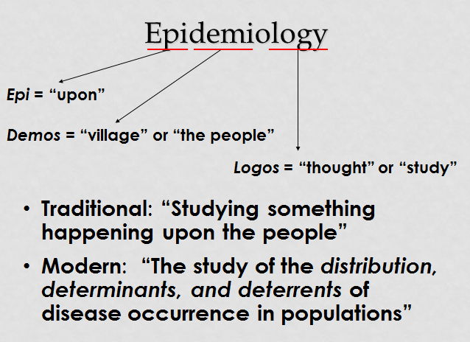

Notes:
Answering Epidemiologic Questions for Zoonoses
 | 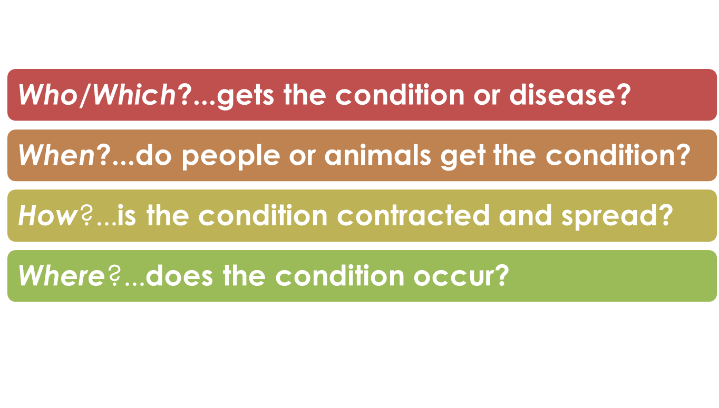  For each zoonoses your instructor provides, answer the basic epidemiologic questions:

Disease | Who/Which | When | How | Where

EPIDEMIOLOGY IN PRACTICE
History and Examples

Learning Objective: |  | - Identify some of the diverse specialties in the field of epidemiology.  - Describe how epidemiology is used by human, animal and environmental health professionals.
 | Epidemiology and Zoonotic Diseases

Lecture

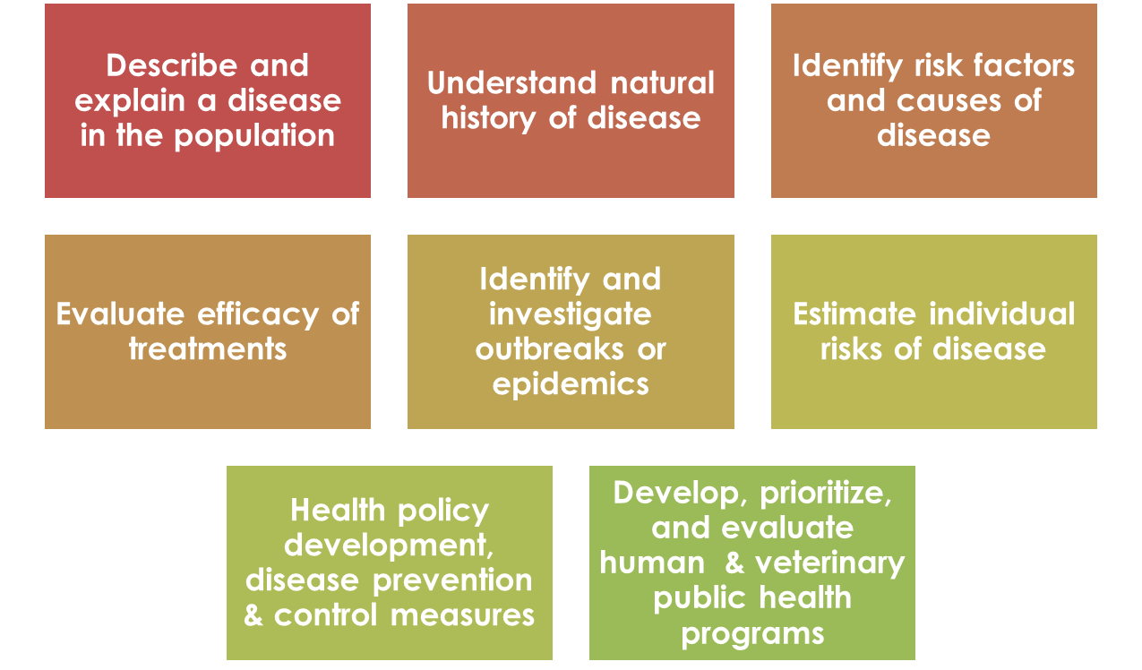
Notes:

EPIDEMIOLOGICAL TOOLS AND METHODS
Learning Objective: | - List methods that can be used for the epidemiological assessment of a health problem.  - Identify ways that public health laboratories carry out epidemiological functions.
Prework
 | Look for various types of images (maps, graphs, charts, tables) that show infectious disease surveillance data and to bring several examples to class. Good sources include Google Images, WHO, OIE, FAO, HealthMap, CDC, and national, and state or local health departments.
www.ucdmc.ucdvis.edu

Tools and Methods

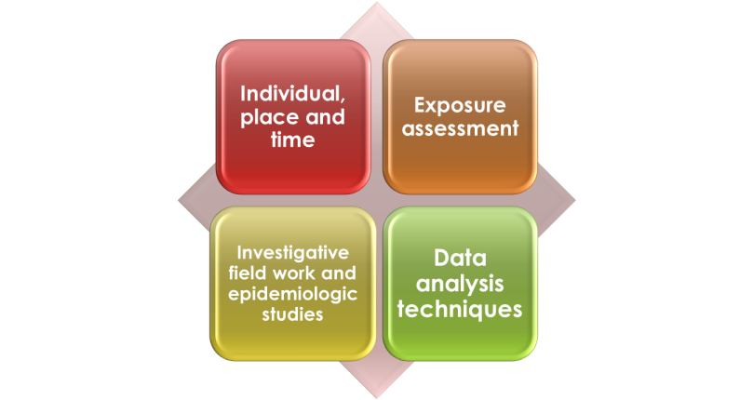

Notes:

What did you find?
Share examples of different ways to display disease surveillance data that you found as you completed the prework for this session.

Notes:

EPIDEMIOLOGY PARTNERS AND RESOURCES
Learning Objective: | - Identify allied health and community partners in the practice of epidemiology.  - List ways in which epidemiologists work with the media and the five components of the WHO Outbreak Communication Guidelines.  Describe how the WHO, OIE, FAO and CDC serve as resources for training, technical support, and surveillance and reporting of epidemiological data.
Prework
 | Find and bring to class articles or reports, preferably in the local and national media (can be print, television, radio) related to health and disease.
Communicating with Partners
WHO Guidelines on Risk Communication During a Crisis

Notes:
DESCRIPTIVE EPIDEMIOLOGY
Learning Objective: | - Define descriptive epidemiology.  - List the two major descriptive epidemiological study designs.  List examples of the use of descriptive data.

Simple Questions with Complex Answers

Lecture | 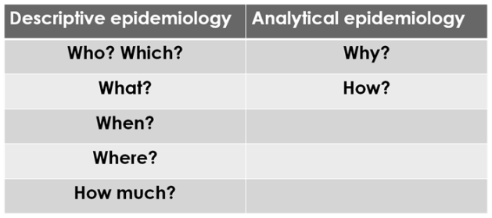
Notes:

Class Exercise - As Assigned by the Instructor

As a class, come up with examples of diseases illustrating the following characteristics of descriptive epidemiology:
- Diseases that have different temporal/seasonal patterns of occurrence (for example, malaria and other mosquito-borne diseases during rainy seasons, influenza and so on)
- Diseases with different spatial patterns of occurrence
- Diseases with different patterns of occurrence by age (young, old) and sex (male, female)
- Brainstorm about lists of diseases that the students consider epidemic. Are there both recent and historical examples (SARS vs. MERS coronavirus, canine rabies, “Spanish flu” and avian influenza, etc.)

Notes:

ANALYTIC EPIDEMIOLOGY
Learning Objective: | - Define analytic epidemiology.  - List three types of observational study designs.

Descriptive Epidemiology
Lecture | 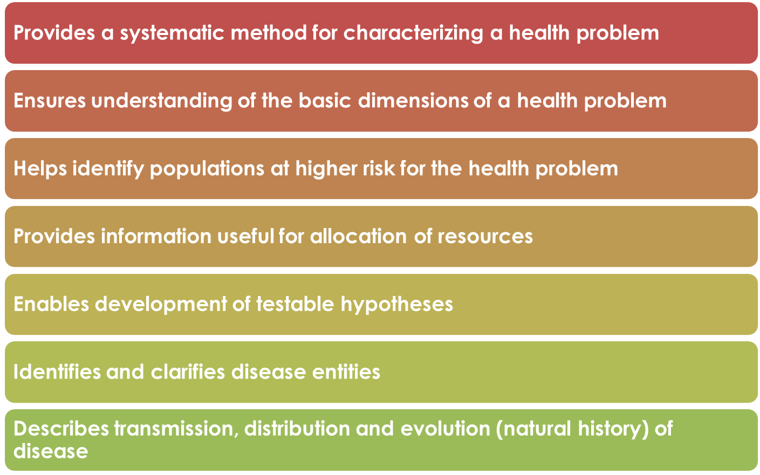

Notes:

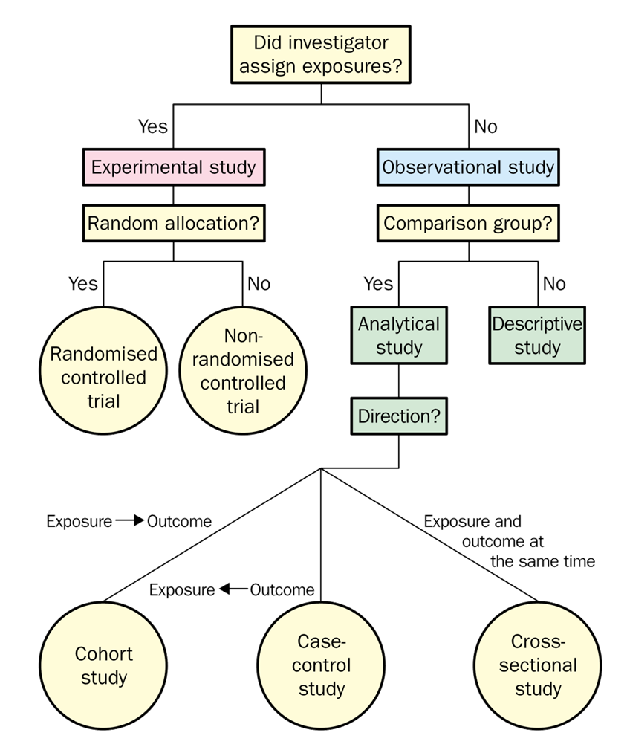

Exercise - As Assigned by the Instructor
As a class, discuss the following types of zoonotic diseases, and decide which type of observational study (from the choice within descriptive and analytic study designs) is best suited to investigation of:
- a newly emerged zoonosis.
- a zoonosis with a long incubation period.
- disease prevalence and incidence.
- a zoonosis in a remote or inaccessible area.

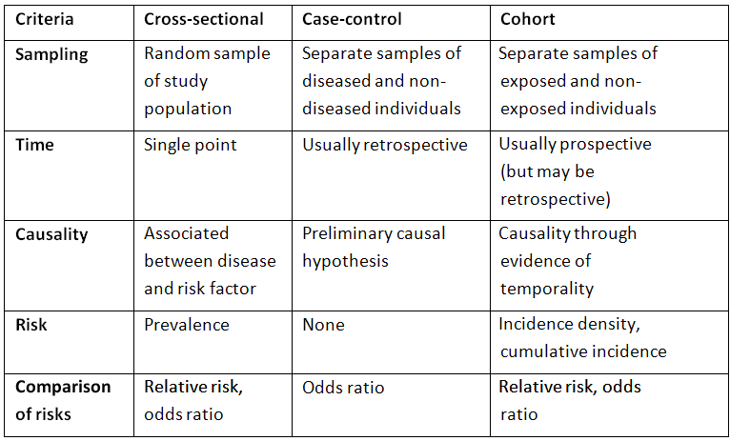
Notes:

STATISTICAL MEASURES IN EPIDEMIOLOGY
Learning Objective: | - Define the most common statistical frequency measures used in infectious disease epidemiology.  - Construct a frequency distribution.
Pre-work
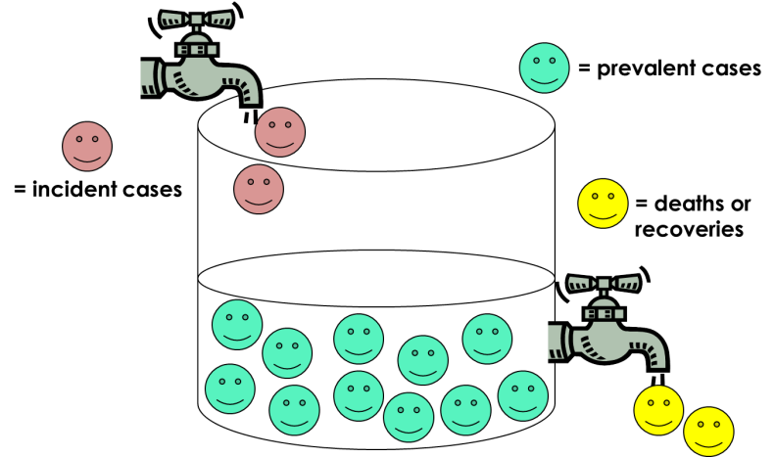

Notes:

PECOT
Teaching Critical Appraisal of Published Epidemiology Literature

LECTO
Learning Objective: | - Explain the basic components of observational epidemiological studies from published peer-reviewed articles.  - Optional: Use the PECOT method to assess completeness and accuracy of popular press reports of epidemiologic studies..

PECOT
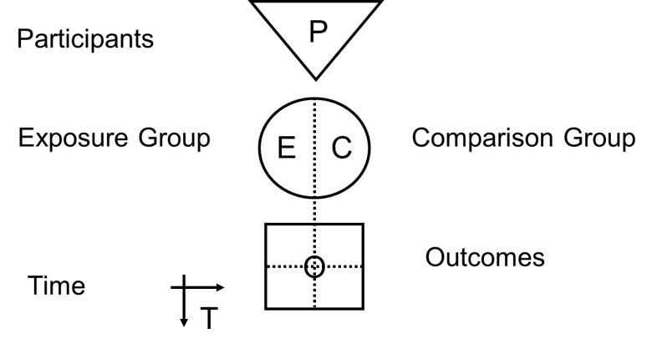

Notes:

Applying PECOT
 | Your instructor will assign you an article to read and interpret using PECOT.  - Prospective Cohort: Khuntirat, B. P., Yoon, I. K., Blair, P. J., Krueger, W. S., Chittaganpitch, M., Putnam, S. D. and Gray, G. C. (2011). Evidence for subclinical avian influenza virus infections among rural Thai villagers. Clinical Infectious Diseases, 53(8), e107–e116.  - Retrospective and Prospective Cohort: Moen, A. R., Wouda, W., Mul, M. F., Graat, E. A. M., and Van Werven, T. (1998). Increased risk of abortion following Neospora caninum abortion outbreaks: a retrospective and prospective cohort study in four dairy herds. Theriogenology, 49(7), 1301–1309.  - Corss-sectional: Suwancharoen, D., Chaisakdanugull, Y., Thanapongtharm, W., and Yoshida, S. (2013). Serological survey of leptospirosis in livestock in Thailand. Epidemiology and infection, 141(11), 2269–2277.  - Case-Control: Parashar, U. D., et. al. (2000). Case-control study of risk factors for human infection with a new zoonotic paramyxovirus, Nipah virus, during a 1998–1999 outbreak of severe encephalitis in Malaysia. Journal of Infectious Diseases, 181(5), 1755–1759.  Be prepared to present your analysis to the class.
Notes:

INTRODUCTION TO DISEASE SURVEILLANCE

LECTO
Learning Objective: | - Understand the relationship between government ministries, local organization, policies, and programs

SMART Surveillance
Strategic…Measurable…Adaptable…Responsive…Targeted

Notes:

Surveillance Websites
Explore the surveillance website assigned to your group:

- US CDC – http://www.cdc.gov/surveillancepractice/
- WHO Global Influenza Surveillance and Response System http://www.who.int/influenza/gisrs_laboratory/en/
- WHO Global Outbreak Alert and Response Network (GOARN) http://www.who.int/csr/outbreaknetwork/en/
- OIE – World Animal Health Information System http://www.oie.int/animal-health-in-the-world/the-world-animal-health-information-system/the-oie-data-system/
- FAO – EMPRES-I http://empres-i.fao.org/eipws3g/#h=0
- European CDC - http://www.ecdc.europa.eu/en/activities/surveillance/Pages/index.aspx
- HealthMap - http://healthmap.org/en/
Directions:
Choose a zoonotic disease and create an evaluation plan for data collection, including procedures and techniques covered in the lecture. Create a poster or flipchart to display your plan and be prepared to share your plan with the class.
Plans will be evaluated on: simplicity, flexibility, acceptability, sensitivity, specificity, accuracy, positive predictive value, negative predictive value, representativeness, sustainability and timeliness.
Notes:

THE CONTAGIOUS CLASSROOM
An Outbreak Investigation

LECTO
Learning Objective: | - Experience a disease outbreak and investigation.  - List the typical steps followed in a disease outbreak investigation.

An Outbreak in Your Classroom
From bubonic plague to malaria to leptospirosis, scientists and public health officials have struggled to understand and contain the spread of infectious diseases. Today, we will simulate a disease outbreak!

 | Person 1 | Person 2 | Person 3 | Person 4 | Person 5 | Person 6 | Person 7
Contact 1
Contact 2
Contact 3

Contact 4

Contact 5

Contact 6

Notes:

What do you think?
- List the steps that you followed in the outbreak investigation. Are any critical steps missing?
- What are the major objectives of a disease outbreak investigation?
Notes:

INTRODUCTION TO DISEASE RISK ANALYSIS

LECTO
Learning Objective: | - Understand the purpose and basic terminology of risk analysis.  - Describe the components of the risk analysis process.  - Give some applications of risk analysis for zoonotic infectious diseases.  - Explain some of the commonly recognized and used risk analysis frameworks.

Risk Assessment, Management and Communication
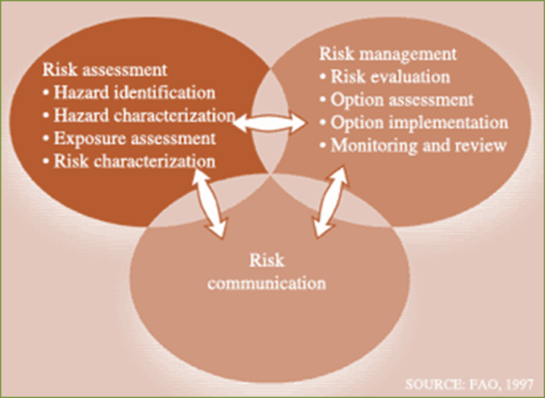
Notes:

Articles on Disease Risk Analysis
Your instructor will assign your group a research article from the list below:
- de Man, H., Bouwknegt, M., van Heijnsbergen, E., Leenen, E. J. T. M., van Knapen, F. and de Roda Husman, A. M. (2014). Health risk assessment for splash parks that use rainwater as source water. Water Research.
- Dom, N. C., Ahmad, A. H., Latif, Z. A., Ismail, R. and Pradhan, B. (2013). Coupling of remote sensing data and environmental-related parameters for dengue transmission risk assessment in Subang Jaya, Malaysia. Geocarto International, 28(3), 258–272.
- Jones‐Engel, L., Engel, G. A., Schillaci, M. A., Lee, B., Heidrich, J., Chalise, M. and Kyes, R. C. (2006). Considering human–primate transmission of measles virus through the prism of risk analysis. American Journal of Primatology, 68(9), 868–879. Abstract available at:
http://www.ncbi.nlm.nih.gov/pubmed/16900498.
- Lau, C. L., Clements, A. C., Skelly, C., Dobson, A. J., Smythe, L. D., and Weinstein, P. (2012). Leptospirosis in American Samoa – estimating and mapping risk using environmental data. PLoS Neglected Tropical Diseases, 6(5), e1669. Article available free online at: http://www.ncbi.nlm.nih.gov/pmc/articles/PMC3362644/.

Analyze the article by answering the questions below:
- What is the framing question?
- What is/are the hazard/hazards identified?
- What are risks?
- Is the risk analysis qualitative, quantitative or both?
- Who are the stakeholders identified?
- Who will be informed of the results?
- How could result be applied?

Notes:
DISEASE Risk Analysis: A Field Exercise for Risk Assessment
Learning Objective: | - Complete a basic risk assessment for a zoonotic disease in a local community.
Preparing for the Field Trip

http://hiddencityphila.org
Notes:

Field Notes
During field trip take notes on practices you observe and all factors that may influence transmission of zoonotic diseases that could impact human health, animal health. Find answers to the following questions:

- Have any zoonotic diseases outbreaks occurred in the community? If yes, focus on this disease.
- What can you observe in the community (jobs, agriculture, livestock kept, food consumed, food and water supply, food preservation, environmental sanitation, waste management, trade and tourism, and so on).
- What animals (livestock, wildlife, pets…) are present? Management systems, environment, animal waste management?
- What ecosystem or ecosystems have been noted? Are any known diseases associated with those ecosystems?
- What factors related to the humans, animals and their environment may impact zoonotic disease transmission?
- Is there access to human and animal health care?

Notes:

REVIEW VOCABULARY AND CONCEPTS BY WATCHING CONTAGION (Optional Activity)

Learning Objective: | - Review vocabulary and concepts of epidemiology (and zoonotic infectious diseases).
Contagion
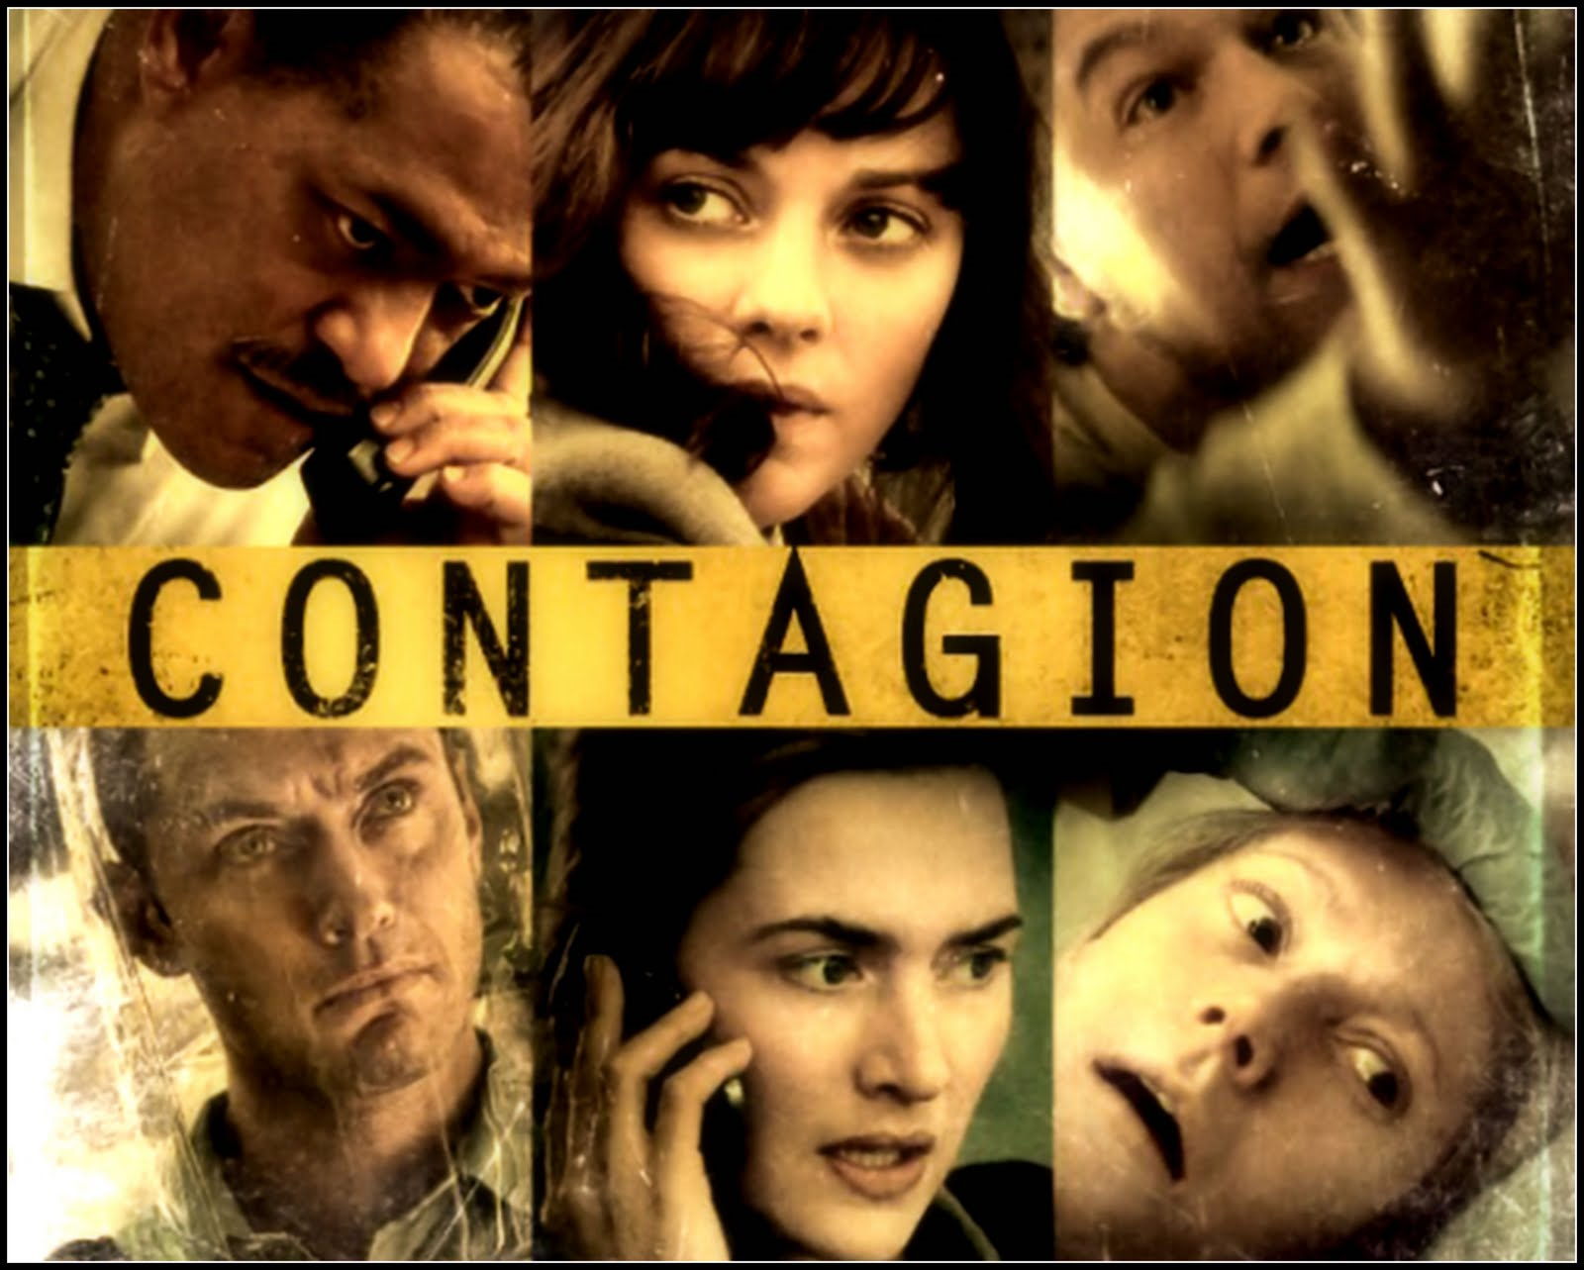 | Watch the movie CONTAGION and as you are watching the move, define as many of the words below as possible.

Vocabulary
- Agent  - Bacteria  - Carrier  - Endemic  - Enzootic  - Epidemic  - Epizootic  - Fomite/Vehicle |  | - Horizontal Transmission  - Host  - Incubation Period  - Index case  - Infective  - Outbreak | - Outbreak curve  - Pandemic  - Parasite  - Pathogen  - R₀  - Recovered  - Reservoir  - Resistant | - Susceptible  - Transmission  - Vaccine  - Vector  - Vertical Transmission  - Virus  - Zoonosis

LEARNING REFLECTIONS & EVALUATION

Learning Objective:
- Reflect your learning in the Epidemiology and Risk Analysis module.
- Provide feedback on what were the strengths of the module and areas that the module could be improved.

Self-Evaluation
  Individual Learning Assessment
  How would you rate your level -- from understanding to being able to apply to being able to evaluate and create --  for the Epidemiology and Risk Analysis: | Understand | Apply | Evaluate/ Create
  Define epidemiology and the basic terminology and concepts used in epidemiology.
  Explain critical components of the practice of epidemiology.
  Analyze national or local public health policies
  Explain the major components in and the process of disease risk analysis and how disease risk analysis links science to policy.
Write down two or three things that you learned from the session. Think about:
- What was new or surprising to you?
- What have you changed your mind about?
- What you are still unsure about?
- What was interesting to you/what would you like to study in more details?
- Are there new behaviors that you will try based on this class?
- What topics from the class will you share with others outside the class?
Notes:

Sharing the Learning
Small Group  Dsicussion | In a small group, share:  - Your key leanings from the module.  - How you will apply the concepts, knowledge, skills you gained from the module.
Notes:

RESOURCES FOR STUDENTS

Homework References Available in the Resource Folder

de Man, H., Bouwknegt, M., van Heijnsbergen, E., Leenen, E. J. T. M., van Knapen, F. and de Roda Husman, A. M. (2014). Health risk assessment for splash parks that use rainwater as source water. Water Research.
Dom, N. C., Ahmad, A. H., Latif, Z. A., Ismail, R. and Pradhan, B. (2013). Coupling of remote sensing data and environmental-related parameters for dengue transmission risk assessment in Subang Jaya, Malaysia. Geocarto International, 28(3), 258–272.
Jones‐Engel, L., Engel, G. A., Schillaci, M. A., Lee, B., Heidrich, J., Chalise, M. and Kyes, R. C. (2006). Considering human–primate transmission of measles virus through the prism of risk analysis. American Journal of Primatology, 68(9), 868–879. Abstract available at: http://www.ncbi.nlm.nih.gov/pubmed/16900498.
Khuntirat, Benjawan P., et. al., Évidence for subclinical avian influenze virus infections among rural Thai villagers,” Clinical Infectious Diseases, 53(8) (2011)
Lau, C. L., Clements, A. C., Skelly, C., Dobson, A. J., Smythe, L. D., and Weinstein, P. (2012). Leptospirosis in American Samoa – estimating and mapping risk using environmental data. PLoS Neglected Tropical Diseases, 6(5), e1669. Article available free online at: http://www.ncbi.nlm.nih.gov/pmc/articles/PMC3362644/
Moen, A.R., Wouda, W., Mul, M.F., Graat, E.A.M., and van Werven, T., “Increased risk of abortion following Neospora caninum abortion outbreaks: a retrospective and prospective cohort study I four dairy herds,” Theriogenology 49 1301-1309 (1998)

Parashar, Umesh, et. al., “Case-control study of risk factors for human infection with a new zoonotic paramyxovirus, nipah virus during a 1998 – 1999 outbreak of severe encephalitis in Malaysia,” The Journal of Infectious Diseases 181:1755-9 (2000)

Suwancharoen, D., Chaisakdanugull, Y., Thanapongtharm, W., and Yoshida, A., Serological Survey of Leptospirosis in Livestock in Thailand, ´Epidemiol. Infect. (2013) 141, 2269-2277

References Available in the Resource Folder

Scurr, John H., Machin, Samuel J., Bailey-King, Sarah, Mackie, Ian J., McDonald, Sally, Smith, Philip D. Coleridge, “Frequency and prevention of symptomless deep-vein thrombosis in ong-haul flights: a randomized trial,” Lancet 357 (2001)
Stirling, Andy C., and Scoones, Jan, “From risk assessment to knowledge mapping: science, precaution, and participation in disease ecology,” Ecoogy and Society 12(2);14 (2009)

World Health Organization (WHO). 2005. Outbreak Communication Guidelines. Available online at Institutional Repository for Information Sharing (IRIS), WHO: http://apps.who.int/iris/handle/10665/69369.

References Available On-Line

Bonita, Ruth; Beaglehole, R; Kjellstrom, T. 2006. Basic epidemiology. World Health Organization, Geneva. Available free online: http://apps.who.int/iris/handle/10665/43541.

European Environmental Agency. Introduction to Risk Assessment Concepts. Available freely online at http://www.eea.europa.eu.

Food and Agriculture Organization of the United Nations (FAO). The Basics of Risk Assessment. Available freely online at www.fao.org.

International Union for Conservation of Nature and the World Organization for Animal Health (IUCN and OIE). 2014. Wildlife Disease Risk Analysis: Handbook of Procedures and Guidelines. Available online from www.oie.int.

Office International des epizooties (OIE) 2010. Handbook on Import Risk Analysis for Animals and Animal Products; Introduction and qualitative risk analysis.
Available online from www.oie.int.

National Research Council. Sustaining Global Surveillance and Response to Emerging Zoonotic Diseases. Washington, DC: The National Academies Press, 2009. Available free online at www.nap.edu.

Ng V, Sargeant JM (2013) A Quantitative Approach to the Prioritization of Zoonotic Diseases in North America: A Health Professionals’ Perspective. PLoS ONE 8(8): e72172. doi:10.1371/journal.pone.0072172. Available free online at http://www.plosone.org.

U.S. General Accounting Office (GAO). West Nile Virus Outbreak – Lessons for Public Health Preparedness. September 2000. GAO/HEHS-00-180. Available free online at http://www.gao.gov/products/GAO/HEHS-00-180.

Veterinarians Without Borders. One Health for One World: A Compendium of Case Studies. Available free online at http://www.onehealthinitiative.com.

World Bank. People, Pathogens and Our Planet. Volume 1: Towards a One Health Approach for Controlling Zoonotic Diseases. Report no. 50833-GLB. 2010. Available online at: http://www.worldbank.org.

