2014|Introduction

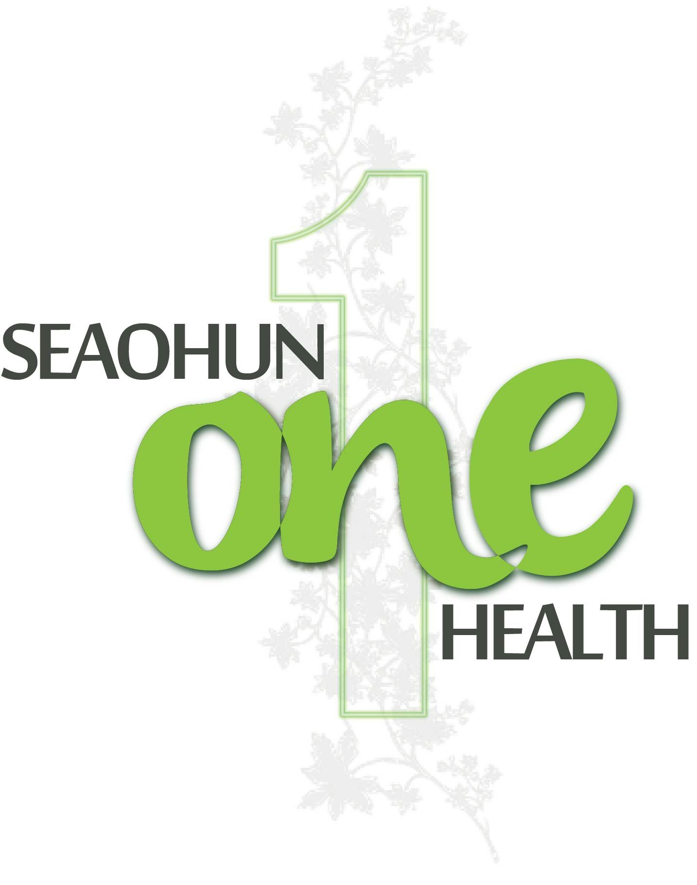



This publication was made possible in part through the support provided by the United States Agency for International Development (USAID). The opinions expressed herein are those of the author(s) and do not necessarily reflect the views of USAID or the US Government. USAID reserves a royalty-free nonexclusive and irrevocable right to reproduce, publish, or otherwise use, and to authorize others to use the work for Government purposes.

14 February 2014

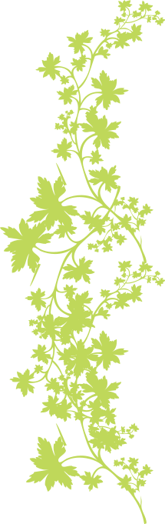

For more information about this course, contact:

Stanley Fenwick
Regional Technical Director RESPOND
Stanley_Fenwick@dai.com

Felicia B. Nutter, DVM, PhD, RESPOND Project
Senior Technical Officer
Tufts University
+1 508 887 4921
Felicia.Nutter@tufts.edu

Roberta Talmage
TRG, Inc.
Arlington, VA 22203
+1 703-875-8909
rtalmage@trg-inc.com

Dear One Health Facilitators:
This course is designed to enhance the ability of professionals who have deep expertise in their discipline to work collaboratively across disciplines to respond to complex One Health problems. The course is comprised of seven technical modules and seven core competencies which will help to build the skills, knowledge and ability of learners to effectively look for answers to public health challenges beyond one’s own discipline and to successfully function as an integral part of a larger, multi-disciplinary, team of professionals.
The seven One Health Core Competency modules are:
- Collaboration and Partnership
- Communication and Informatics
- Culture, Beliefs, Values and Ethics
- Leadership
- Management
- Policy, Advocacy and Regulation
- Systems Thinking
The seven One Health technical modules are:
- One Health Concepts and Knowledge
- Fundamentals of Infectious Disease
- Infectious Disease Management
- Epidemiology and Risk Analysis
- Fundamentals of Public Heath
- Ecosystem Health
- Behavior Change

These modules have been designed to enable you to adapt the content to your specific location (university, region, country, etc.), learners and context. For example, you may want to adapt the field exercises to health care or wildlife facilities in your area; or you may want to focus on the zoonotic diseases that are most prevalent in your region. If you are teaching graduate students rather than undergraduate students, you may want to supplement the assignments and readings with additional academic work. You may be incorporating certain of these One Health modules into a semester course for undergraduates, adapting the materials for a workshop for professionals, or modifying them to present to community stakeholders. Each module has been designed with the flexibility to meet these adaptations. Get creative and make the material work for you.

Modeling the One Health approach, 33 professionals from disciplines ranging from veterinary science to medicine to public health to ecology to instructional design, across five countries including Indonesia, Malaysia, Thailand, Vietnam and the United States, worked together for almost a year to create these One Health Course modules. In the process, we became colleagues and friends. It is in this spirit that we share our work with you.
Sincerely,

Dr. Abu Tholib Aman  Mr. Irwin Fernandez Chavez  Dr. Jeein Chung  Dr. Ede Surya Darmawan  Dr. Stanley Fenwick  Ms. Louise Flynn  Dr. Karin Hamilton  Dr. Latiffah Hassan  Dr. Douglas L. Hatch  Dr. Raymond R. Hyatt  Ms. Kimberly Kennedy | Dr. Nongyao Kasatpibal  Dr. Sumalee Lirtmunlikaporn  Dr. Roslaini Bin Abd. Majid  Dr. Mohd Rizal Abdul Manaf  Dr. Walasinee Moonarmart  Dr. Saengduen Moonsom  Ms. Pornthip Rujisatian  Dr. Sarmin MP  Dr. Pham Hong Ngan  Dr. Felicia Nutter  Dr. Mohd Sham Bin Othman | Dr. Pham Duc Phuc  Dr. Trioso Purnawarman  Dr. Jennifer Steele  Dr. Agik Suprayogi  Ms. Roberta Talmage  Dr. Metawee Thongdee  Dr. Kriangkrai Thongkorn  Mr. Luu Quoc Toan  Dr. Ronald Morales Vargas  Dr. Le Thi Huong  Dr. Le Thi Thanh Xuan

TABLE OF CONTENTS

RESPOND, One Health and SEAOHUN 1
SEAOHUN One Health Competency Framework 2
One Health Course Modules 3
Detailed Overview of the Modules 4
How to Localize and Customize the Modules 18
Role of One Health Educator/Facilitator 22
Using Questions in the One Health Modules 25
Student Learning: Reflections and Evaluation 28
One Health Module Resources 31
Setting Up the Classroom 32
Comments and Suggestions 33

Modules
- Collaboration and Partnerships
- Communication and Informatics
- Culture, Beliefs, Values and Ethics
- Leadership
- Management
- Policy, Advocacy and Regulation
- Systems Thinking
- One Health Concepts and Knowledge
- Fundamentals of Infectious Disease
- Infectious Disease Management
- Epidemiology and Risk Analysis
- Public Heath
- Ecosystem Health
- Behavior Change

RESPOND AND ONE HEALTH


One World. One Medicine. One Health.
The One Health concept is a worldwide strategy for expanding interdisciplinary collaborations and communications in all aspects of health care for humans, animals and the environment. The synergism achieved will advance health care for the 21st century and beyond by accelerating biomedical research discoveries, enhancing public health efficacy, expeditiously expanding the scientific knowledge base, and improving medical education and clinical care. When properly implemented, it will help protect and save untold millions of human and animal lives in present and future generations.

The RESPOND Program
The RESPOND program, built on One Health concepts, is part of USAID’s Emerging Pandemic Threats (EPT) program. RESPOND builds capacity in high-risk countries to control the spread of infectious diseases by connecting government officials, university faculty, civil society and private sector practitioners from the human, domestic animal, and wildlife health sectors. With these partners, RESPOND is building comprehensive disease management systems and strengthening outbreak response capacity to prevent emerging infectious diseases from spreading locally, across borders and abroad.
SEAOHUN - South East Asia One Health University Network
SEAOHUN was created to foster a sustainable trans-disciplinary building of capacity to respond to emerging and reemerging infectious and zoonotic diseases in South East Asia. Ten universities, from four countries—Indonesia, Malaysia, Thailand and Vietnam—are currently in the network. SEAOHUN’s mission is to leverage the training, education and research capacities of the university network to build the skills, knowledge and attitude base for One Health leaders.

SEAOHUN ONE HEALTH COMPETENCY FRAMEWORK

The RESPOND One Health Core Competency (OHCC) initiative involved the South East Asia One Health University Network (SEAOHUN), the One Health Central and East Africa (OHCEA) university network, along with U.S. partner organizations in the building of a competency framework on which One Health curricula can be designed and initiated. The OHCC framework encompasses three levels of program and curriculum development:
- Country-level competencies to facilitate curriculum development to meet the needs of institutions and programs within a specific country
- Regional competencies to facilitate coordination of curriculum development within a regional network such as SEAOHUN or OHCEA
- Global competencies to facilitate sharing curriculum development across regional and network boundaries

Within this framework, core competencies are defined as knowledge, behaviors and attitudes needed by every member of a One Health outbreak team for prevention, disease surveillance or response. The table below shows the OHCC core competencies, the SEAOHUN regional competencies, and the country competencies for Malaysia, Indonesia, Thailand and Vietnam.

RESPOND ONE HEALTH COMPETENCY FRAMEWORK
Global Domains February 2014 | SEAOHUN Regional Domains | Malaysia | Indonesia | Thailand | Vietnam
Management | Management | Management | Management | Planning and Management | Planning and Management
Communication | Communications and Informatics | Communication | Communication | Communications and Informatics | Communications and Informatics
Culture and Beliefs | Culture and Beliefs | Culture and Belief | Culture and Belief | Culture and Ethics | Culture and Beliefs
Leadership | Leadership | Leadership and Professionalism | Leadership and Professionalism | Leadership | Leadership
Collaboration and Partnership | Collaboration and Partnership | Collaboration and Partnership | Collaboration | Collaboration and Partnership` | Collaboration and Partnership
Values and Ethics | Values and Ethics | Ethics | Values and Ethics |  | Values and Ethics
Systems Thinking | Systems  Thinking | Systems Thinking | Systems Thinking | Systems Thinking | Systems Thinking
 |  |  |  | One Health Knowledge | Policy, Regulation and Advocacy

ONE HEALTH COURSE MODULES

The One Health Course is comprised of fourteen modules: seven core competencies and seven technical modules.

The core competency modules are:  - Collaboration and Partnership  - Communication and Informatics  - Culture, Beliefs, Values and Ethics  - Leadership  - Management  - Policy, Advocacy and Regulation  - Systems Thinking  The core competencies are fundamental to the technical modules as they provide the skills and knowledge for applying technical expertise in a One Health context. These competencies are interdependent. For example: behavior change requires that the One Health professional understands how culture and beliefs shape an individual’s and a community’s attribution of disease; public health requires leadership and collaboration to develop and implement policies and regulations.  The technical competencies also are interdependent. For example, Infectious Disease Management requires an understanding of the fundamentals of infectious disease and behavior change. | The technical modules are:  - One Health Concepts and Knowledge  - Fundamentals of Infectious Disease  - Infectious Disease Management  - Epidemiology and Risk Analysis  - Public Heath  - Ecosystem Health  - Behavior Change  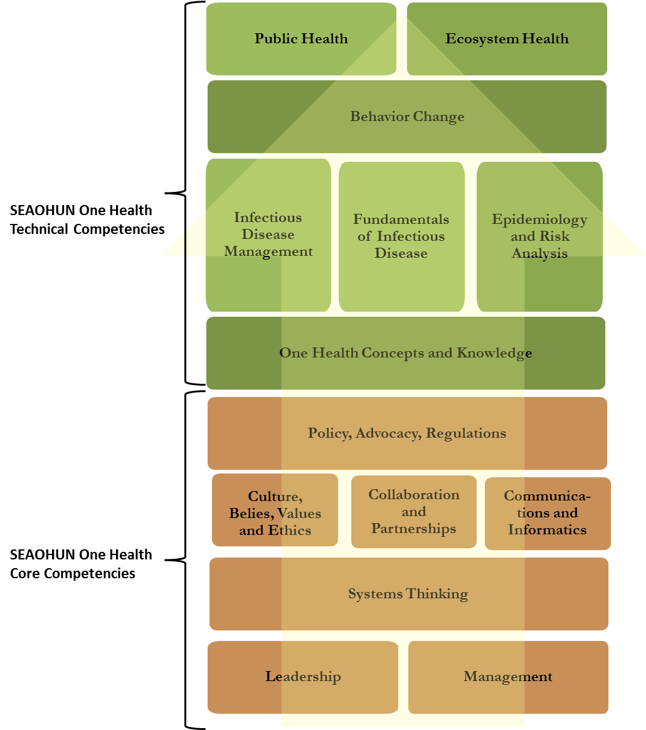

You will see overlap among the modules. For example, there are lessons on stakeholder analysis in the “Communication and Informatics” module, the “Policy, Advocacy and Regulations” module and the “Fundamentals of Infectious Disease” module. As professors and trainers adapt the materials for your students, you may want to look at how similar skills and knowledge are developed in different modules so that you can chose an approach that best fits your desired learning outcomes.

DETAILED OVERVIEW OF THE MODULES

Collaboration and Partnerships Module
At the heart of One Health is the ability to form partnerships and collaborate across disciplines. This module builds an understanding of and aptitude in the basic principles of collaboration and partnership, in the context of a One Health approach to addressing complex health challenges. The module uses the “Marshmallow Challenge,” a fun and instructive exercise, to allow students to experience simple but profound lessons in collaboration, innovation and creativity.

Competencies
- Promote inclusion of representatives of diverse constituencies across human, animal, environmental health and other relevant disciplines
- Share vision, power, responsibility, accountability and credit among collaborators

Sessions
Time/Length | Topic
30 Minutes | Introduction
120 Minutes | What is Collaboration and Why Collaborate?
450 Minutes | How Do You Collaborate Successfully?
60–240 Minutes | Practice Collaboration
60 Minutes | Learning Reflections and Evaluation

Communication and Informatics Module

This module fosters an understanding of effective communication and information-sharing across disciplines and sectors. Students will learn about verbal and non-verbal communication as they practice the critical communication skills of listening, asking open-ended questions and paraphrasing. They will apply these skills as they practice developing and delivering One Health messages to a range of stakeholders.

Competencies
- Describe basic communication techniques and tools (e.g., written communication, multi-media, social media, interactive discussion, listening).
- Understand the fundamentals of risk communication.
- Understand a variety of ways to manage and share information.

Sessions
Time/Length | Topic/Activity
105 Minutes | Communication Skills
90 Minutes | One Health Promotion Communication Strategies
60 Minutes | Introduction to Risk Communication
60 Minutes | Delivering Risk Communication Messages
180 Minutes | Communicating With/Through the Media
335 Minutes | Understanding a Variety of Ways to Manage and Share Information
60 Minutes | Learning Reflections and Evaluation

Culture, Beliefs, Values and Ethics Module

This module provides learners with an understanding of culture, beliefs, values and ethics at the individual and societal levels, which is critical when working across disciplines and contexts to achieve One Health goals. Through simulations, research and small group exercises, students will study social, gender, religious and historical diversity and develop skills to work professionally with One Health stakeholders across sociocultural differences.

Competencies
- Identify and interpret local norms, wisdom and culture about human, animal and environmental health.
- Generate trust among the community within One Health interventions.
- Demonstrate values, ethics and professionalism in planning and implementing One Health interventions.

Sessions
Time/Length | Topic/Activity
75 Minutes | Introduction to Culture and Health Beliefs
90 Minutes | Cultural Dimensions and Models
135 Minutes | Culture and Gender
90 Minutes | Culture and Animals
60 Minutes | Culture and the Environment
600 Minutes | Creating Trust Across Cultures - Field Observation
270 Minutes | Personal Values and Professionalism
60 Minutes | Protecting Human Subjects During Research
60 Minutes | Learning Reflections and Evaluation

Leadership Module

This module discusses leadership in the context of One Health as the ‘ability to catalyze collective action for positive change.’ In this module, students will explore the range of leadership skills, knowledge and behaviors that One Health professionals must demonstrate to be effective in their work, examine their own personal leadership styles and the impact it has on their ability to work in groups and review techniques for empowering others to take collective action.

Competencies
- Discuss what leadership is and how cultural and sectoral lenses impact our perceptions of effective leadership.
- Demonstrate an understanding of effective leadership in the One Health context.
- Understand and adapt personal leadership styles.
- Develop and apply strategies for engaging and empowering others to take collective action.

Sessions

Time/Length | Topic/Activity
145–245 Minutes | Introduction to Leadership
160 Minutes | The Role of Leadership in One Health
135 Minutes | Leadership Styles
60 Minutes | Adapting Your Leadership Style – Working Collectively
205 Minutes | Engaging and Empowering Others to Take Action: Part I
165 Minutes | Engaging and Empowering Others to Take Action: Part II
60 Minutes | Learning Reflection and Evaluation

Management Module

Following Peter Drucker’s premise that leadership is about doing the right thing and management is about doing things right, this module focuses on the management skills of work planning, monitoring and anticipating problems and finding solutions. The module provides basic Six Sigma tools for effective project management. In addition, the module looks at how a manager can help a One Health team recognize and manage stress so that the team can be effective in responding to an emerging pandemic threat.

Competencies
- Understand the difference between managing and leading and the importance of each to a successful One Health initiative.
- Develop work plans to plan and monitor progress.
- Ensure policies, procedures and systems are in place to guide and support the One Health initiative.
- Oversee implementation and monitor the initiative to maximize the effectiveness of One Health actions and desired outcomes.
- Overcome barriers, solve problems and apply corrective active during One Health initiatives. Evaluate and share learning post-initiative.
- Ensure the safety and well-being of the One Health team.

Sessions
Time/Length | Topic/Activity
60 Minutes | Introduction to One Health Management
120 Minutes | Work Plans: The Key to Successful One Health Initiative Management
120 Minutes | Policies and Procedures: The Key to Guiding and Supporting One Health Initiatives
180 Minutes | Tools for Managing One Health Initiatives
90 Minutes | Monitoring Implementation to Achieve Outcomes
120 Minutes | Managing Team Health
60 Minutes | Learning Reflections and Evaluation

Policy, Advocacy and Regulation Module

This module fosters an understanding of policy frameworks conducive to achieving One Health outcomes. In the module, students will identify national and international regulatory bodies, conduct an in-depth study of the International Health Regulations of the World Health Organization (WHO), and consider how to strengthen existing policies, regulations, guidelines and procedures by adopting a One Health perspective. Students will learn about and practice how to advocate for policy change.

Competencies
- Identify and understand the role of international agencies and their policies that affect One Health.
- Identify and understand the role of national ministries/agencies and their policies that affect One Health issues.
- Advocate for a policy that addresses One Health issues.
- (Advanced) Analyze the effects of regional and local policies, economics and culture on One Health issues.

Sessions
Time/Length | Topic/Activity
30 Minutes | Introduction
120 Minutes | Policies, Regulations, Guidelines, Procedures, and Position Papers: Definitions and International Organizations that Create Them
60 Minutes | Anatomy of an International/Intergovernmental Policy
60 Minutes | Analyzing WHO, OIE and FAO Policies, Regulations, Guidelines and Policy Papers
150 Minutes | Discovering National Policies
90 Minutes | Becoming an Advocate for One Health Policies
90 Minutes | Policy Advocacy in Action
60 Minutes | Learning Reflections and Evaluation

Systems Thinking Module

Using a problem-based learning approach, this module provides students with the skills necessary to take a systems thinking approach to emerging pandemic diseases. Key outcomes of this module are the ability to: use systems thinking to create maps of complex and complicated systems that include human, animal, environment and ecological components; and to operate as part of a One Health team that uses systems maps to develop solutions to complex problems, integrating information from multiple disciples and sectors, to develop strategies to address One Health challenges, and to anticipate and mitigate potential unintended consequences of One Health actions.

Competencies
- Describe the elements of complex problems and systems thinking.
- Create and use systems mapping to deepen understanding of One Health problems.
- Partner with One Health team members to develop solutions to complex One Health problems using systems thinking and tools.

Sessions
Time/Length | Topic/Activity
30 Minutes | Introduction
60 Minutes | What is Systems Thinking?: The Learning Challenge
180 Minutes | What is Systems Thinking?: The Exploration
60 Minutes | What is Systems Thinking?: Sharing the Learning
90 Minutes | Wicked Problems: Finding Solutions to One Health Problems through Systems Thinking
60 Minutes | Wicked One Health Problems: Sharing Solutions
60 Minutes | Learning Reflections and Evaluation

One Health Concepts and Knowledge Module

With games, Wordles, and debates, students will learn the history of One Health, the array of disciplines that must work together to solve some of the world’s most difficult health issues, and important One Health terms and concepts. Students will be able to explain the importance of taking a perspective that integrates human, animal and ecology health to respond and control emerging pandemic threats.

Competencies
- Explain the history and concept of One Health.
- Describe the One Health Core Competency (OHCC) domains and their application.
- Describe the application of the One Health approach.

Sessions
Time/Length | Topic/Activity
90 Minutes | One Health Knowledge
70 Minutes | Who Might be on a One Health Team?
90 Minutes | One Health Core Competency (OHCC) Domains
60 Minutes | The “Approach vs. Discipline” Debate
120 Minutes | One Health in Action: “My Problem is Real”
60 Minutes | Learning Reflections and Evaluation

Fundamentals of Infectious Disease Module

This module fosters an understanding of the basic principles of infectious diseases in the context of One Health. The module will use a One Health approach to examine various important zoonotic infectious diseases of humans and animals and help students understand the fundamentals of infectious disease spread and their impact on daily life.

Competencies
- Describe the fundamental concepts of infectious diseases
- Interpret the fundamentals of infectious diseases and the impact in daily life
- Identify problems relating to culture and traditional practices (e.g. livestock, sanitation)
- Integrate the respective elements of fundamental concepts of infectious disease
- Apply various communication strategies in writing, oral presentation, and role-plays

Sessions
Time/Length | Topic/Activity
420 Minutes | Fundamental Concepts of Infectious Disease
120 Minutes | One Health Team Role-Playing
120 - 180 Minutes | Issues in Daily Life Related to Infectious Disease
90 Minutes | Human Impacts on Infectious Disease
90 Minutes | Natural Disasters and Infectious Disease Role-Playing Activity
150 - 210 Minutes | Culture and Tradition in the Local Community – Field Trip
120 - 180 Minutes | Developing a Systems Map for an Infectious Disease
180 Minutes | Create Messages to Convey Infectious Disease Information
60 Minutes | Learning Reflections and Evaluation

Infectious Disease Management Module

Infectious disease management is a comprehensive way of thinking and looking at the problem of infectious disease using multiple perspectives over the whole spectrum of disease management including surveillance, health promotion, prevention, detection, treatment and rehabilitation from the perspective of host/agent/environment. This module fosters an understanding of the concept of One Health programs in infectious disease management at the individual and societal levels, which is critical to working across disciplines and contexts to achieve the goals of One Health. Students will also understand the interplay among agent, host and environment, in developing interventions to control outbreaks and strategies to eradicate disease.

Competencies
- Identify and analyze the risk factors associated with illness during an infectious disease outbreak or epidemic.
- Design an infectious disease management plan.
- Evaluate the effectiveness of One Health actions in infectious disease management.
- Design a disease surveillance and monitoring system.

Sessions
Time/Length | Topic/Activity
180 Minutes | Module Introduction and Basic Concepts
100 Minutes | Describing Infectious Disease Risk Factors in an Outbreak Scenario
180 Minutes | Creating a Map to Visualize Risk Factors and Control Points
360 Minutes | Risk Assessment in a Local Community
300 | Collecting Community-Based Data to Support Infectious Disease Investigations or Risk Assessments
240 - 300 Minutes | Develop Public Awareness Materials for Infectious Disease
60 - 120 Minutes | Critique an Infectious Disease Management Plan using a One Health Perspective
60 Minutes | Describe Systemic Effects of a Management Plan
150 Minutes | Examine an Existing Surveillance System
150 Minutes | Analyze surveillance data using HealthMap
60 Minutes | One Health Team Role-Playing Activity to Develop a Management and Surveillance Plan
60 Minutes | Learning Reflections and Evaluation

Epidemiology and Risk Analysis Module

Epidemiology, epizootiology and population health are all terms describing the study of health and disease in populations, as distinct from individuals. Risk analysis is a systematic approach to evaluating both the likelihood of occurrence and the magnitude of impact if a particular adverse event occurs, and taking steps to mitigate that risk and communicate with relevant stakeholders and populations. Epidemiology and risk analysis are both important to the practice of the One Health approach, and professional health science programs incorporate these topics to some degree in their curricula. Recognizing that a One Health approach is broad and includes many disciplines distinct from health sciences (such as economics, social sciences, law and policy, and many others), this module is designed to introduce those with little or no background in epidemiology to the history, concepts, theories, terminology and practice of epidemiology, to improve their ability to collaborate with epidemiologists.

Competencies
- Define epidemiology and the basic terminology and concepts used in epidemiology.
- Explain critical components of the practice of epidemiology.
- Explain the major components in and the process of disease risk analysis and how disease risk analysis links science to policy.

Sessions
Time/Length | Topic/Activity
15 Minutes | Introduction
30–45 Minutes | Epidemiology is a Basic Public Health Science
60 Minutes | Epidemiology in Practice: History and Examples
60 Minutes | Epidemiological Tools and Methods
60 Minutes | Epidemiology Partners and Resources
60 Minutes | Descriptive Epidemiology
180 Minutes | Analytic Epidemiology
120 Minutes | Statistical Measures in Epidemiology
60–180 Minutes | PECOT: Teaching Critical Appraisal of Published Epidemiology Literature
180 Minutes | Introduction to Disease Surveillance
90 Minutes | The Contagious Classroom: An Outbreak Investigation
60–120 Minutes | Introduction to Disease Risk Analysis
Variable | Disease Risk Analysis: Field Exercise for Risk Assessment
240 Minutes | Optional: Review Vocabulary and Concepts by Watching Contagion
60 Minutes | Learning Reflections and Evaluation

Public Heath Module

This module brings a One Health approach to public health by looking at the interface among human, animal and ecological health as students explore how to prevent disease and promote health within groups of people, from small communities to entire countries. Topics in this module include air quality, water quality/sanitation, food safety/security, epidemiology/biostatistics, maternal/child health and social science as students are introduced to critical public health topics. The module includes discussions on policy and stakeholder involvement.

Competencies
- Understand public health practice and its relationship to One Health.
- Understand the interrelationships among government authorities, policymakers, industry and researchers related to implementation of public health programs.
- Analyze national or local public health policies.
- Use systems thinking to analyze/create a public health policy.

Sessions
Time/Length | Topic/Activity
60 Minutes | Introduction to Public Health
60 Minutes | Ecosystem Health, Climate Change and Public Health
120 Minutes | Animals and Public Health: Human/Wildlife Interactions (Zoonoses)
180 Minutes | Animals and Public Health: Human/Domestic Animal Interactions
360 Minutes | Foodborne Diseases, Food Safety and Food Production
60 Minutes | Water Quality, Sanitation and Waterborne Disease
60 Minutes | Disease Monitoring and Surveillance: Basic Epidemiological Terms/ Disease Investigation
90 Minutes | Disease Monitoring and Surveillance: Local and Global Surveillance
240 Minutes | Community Health
120 Minutes | Policies and Programs
60 Minutes | Taking a One Health Approach to Public Health Policies and Programs
90 Minutes | Systems Thinking: Building Stakeholder Consensus Using a One Health Approach to a Public Health Issue
60 Minutes | Learning Reflections and Evaluation

Ecosystem Health Module

This module fosters an understanding of the basic principles of ecosystem health in the context of One Health. Students will explore three South East Asian ecosystems—mangroves, tropical rainforests and coral reefs—and analyze how natural and anthropogenic changes to the environment can affect animal and human health locally, regionally and nationally. The capstone of the module is a real-world simulation in which students discover the questions they need to ask about the impact of extractive industries on human, animal and ecological health.

Competencies
- Understand fundamental ecological/ecosystem principles.
- Recognize the interrelationships among ecosystems, animal health and human health.
- Analyze the effects of direct impacts on the environment.

Sessions
Time/Length | Topic/Activity
60 Minutes | Introduction to Ecosystem Health
60 Minutes | Abiotic Cycles - Overview of Water, Carbon and Nitrogen
60 Minutes | Biotic Cycles, Food Webs and South East Asia Ecosystems
90–110 Minutes | Ecosystems of South East Asia: Values and Services
80 Minutes | Factors that Disrupt Ecosystems: Natural and Man-Made
60 Minutes | Effect of Disruption of Ecosystems and the Impacts on Human and Animal Health: Local, Regional and National Scales
60 Minutes | Climate Change, Ecosystems, Human and Animal Health
60 Minutes | Gold Mining Simulation
60 Minutes | Learning Reflections, Evaluation and Optional Final

Behavior Change Module
In this module, students use research and models for behavior modification from a health care context to develop behavior change models for One Health interventions in which human behavior change impacts not only human health, but also animal and ecological health. The first half of the module addresses individual behavior change; the second half addresses organizational and community change.

Competencies
- Explain behavior change theories and change management concepts.
- Adapt and apply models for individual behavior change for One Health contexts.
- Demonstrate cultural competency and professionalism in leading change.
- Design behavior change strategies for One Health interventions in communities.

Sessions
Time/Length | Topic/Activity
--- | Pre-work: Personal Behavior Change Experience
60 Minutes | Debrief Pre-work and Introduction to Behavior Change
60 Minutes | Professional-Directed and Patient-Centered Behavior Change Approaches
60 Minutes | Models for Patient-Centered Change: The Health Belief Model
120 Minutes | Models for Patient Centered Change: Readiness to Change and Motivational Interviewing
180 Minutes | Models of Organization and Community Change: Kotter and Lewin
120 Minutes | Behavior Change in One Health Interventions
60 Minutes | Learning Reflections and Evaluation

HOW TO LOCALIZE AND CUSTOMIZE THE MODULES

The One Health Course is designed to meet the requirements set forth by the One Health Core Competencies (OHCC) Working Group. The Working Group required that the One Health Course:

- Have country ownership and involve SEAOHUN faculty and administrators in developing the curriculum.
- Be flexible to fit into existing courses.
- Be adaptable to in-service training or pre-service programming.

One Health Core Competency (OHCC) Framework
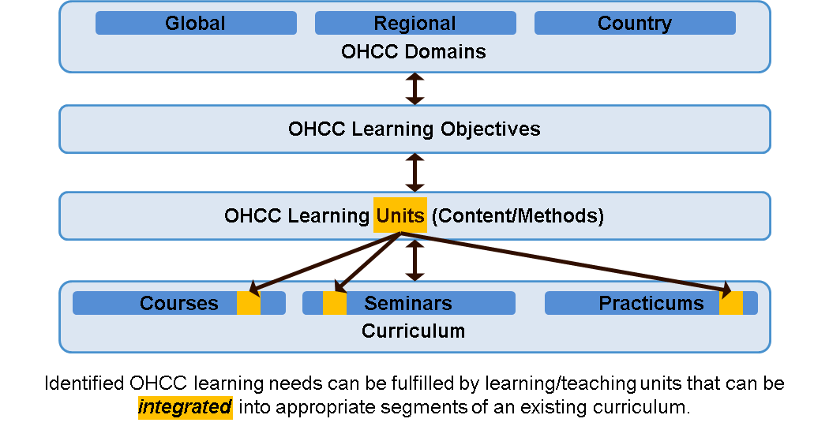

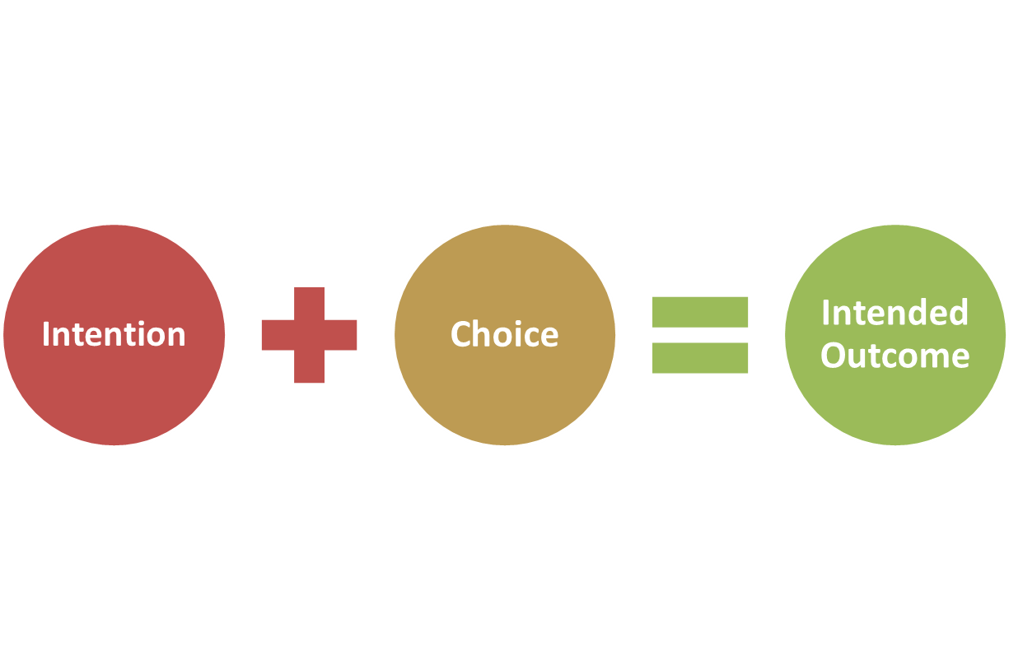
To meet the OHCC requirements, the instructor/facilitator, having the choice of which materials and how precisely to present these materials, remains an underlying principle of the One Health Course design.

CHOICE: A One Health instructor/facilitator may choose to teach the core competencies as stand-alone (independent) modules or may choose to integrate them into the technical modules.
The OHCCs are inter-dependent and so may be taught either separately or in combination with the technical skills. For example, a thorough understanding of culture and communication is critical to successfully changing stakeholder behavior. A One Health instructor/facilitator may prefer to teach culture and communication skills separately or to integrate these concepts into their teaching about behavior change.
CHOICE: A One Heath instructor/facilitator may choose to combine elements of the modules.
The modules are comprised of sessions covering different topics. The instructor/facilitator can select lessons that will be most useful for the students and may choose to combine topics from different modules that best fit the learning need or local health context.
CHOICE: A One Health instructor/facilitator may choose to teach specific sessions of a module rather than an entire module.

CHOICE: A One Health instructor/facilitator may choose to use the modules to create a new unit in an existing course or to create a One Health “short course.”
The modules can be used as stand-alone courses, as lessons added into existing courses or can be combined to create a new One Health course.
CHOICE: A One Health instructor/facilitator may choose to localize content and change the context.
The modules are designed to be localized. For example, if a region is more prone to avian influenza than Ebola, the instructor may want to change the disease being discussed. The exercises within a module can be changed to reflect the local context. For example, the Public Health module has learners conduct a public health audit. If the course is taking place at a university, students can audit campus facilities; if the course is being taught in a small town, learners can audit a local medical facility, market or other section of the town.
CHOICE: A One Health instructor/facilitator can tailor the modules to the audience of learners.
The modules can be adapted to the student. If the course is for graduate students, the instructor can focus more on theory and research and supplement the reading and assignments with more advanced materials. If the course is a short course for professionals, the instructor can focus on applied concepts and practical, hands-on activities.

How to Adapt the One Health Course to Meet Your Needs

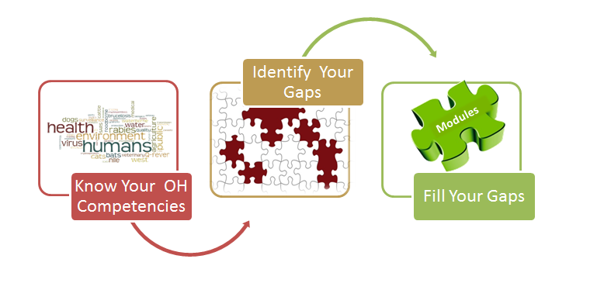
- Step One: Know your One Health competencies.
- Step Two: Review your curricula and identity which competencies are not covered OR if you are designing a new course or a short-course, identify which competencies you want to cover.
- Step Three: Use the One Health Course materials to fill the gaps.

Below are examples of potential “One Health in One Day” courses for four different audiences:

ACADEMICS |  | GOVERNMENT & POLICY MAKERS
- Introduction to One Health  - Infectious Disease, Epidemiology and Policy Concepts  - One Health Simulation  - Leader Styles  - Leadership Self-Assessment Test  - Systems Mapping  - One Health Simulation (continued)  - Collaboration/Partnership and Communication  - One Health Simulation (continued)  - Individual Reflections on Behavior Change |  | - Introduction to One Health Concepts  - Concepts and Terminology (Presentation)  - Leadership  - Leadership Style (Self-Assessments and Group Discussion)  - Management  - Successful One Health Initiatives (Speaker)  - Six Sigma Management Tools (Group Projects)  - Collaboration  - Collaborating in Parliament (Simulation)

HEALTH PRACTITIONERS |  | GRADUATE H&S STUDENTS
Simulation: “Orang Utan, Palm Oil, Tuberculosis and the Environment”  - Morning simulation uses content from:  - Ecosystem Health  - Culture, Beliefs, Values and Ethics  - Epidemiology and Risk Analysis  - Fundamental of Infectious Disease  - Infectious Disease Management  - Behavior Change  - Afternoon continues with the simulation focusing on content from:  - Policy, Advocacy and Regulation  - Systems Thinking  - Collaboration and Partnership  - Communication and Informatics |  | - One Health Concepts and Knowledge  - Concepts and Domains (Presentation)  - Jeopardy (Game)  - Systems Thinking  - Discovering Systems Thinking (PBL)  - Mapping Stakeholders (Group Exercise)  - Ecosystems Health (Presentation)  - Risk Communication  - Infectious Disease (Simulation)  - Collaboration and Partnerships  - Agencies Involved in Policy (Discussion)  - Working Together for a One Health Approach (Group Exercise)

ROLE OF A ONE HEALTH EDUCATOR/FACILITATOR

The One Health modules are designed using a learner-centered approach, which means that a One Health educator plays a very different role from a traditional classroom teacher. Your role becomes much more of a mentor/coach/guide, posing challenging questions and facilitating learning experiences inside and outside of the classroom.

- As an educator, you are always ensuring that content researched and developed by learners is complete and accurate.
- As a learning mentor or coach, you are continually assessing your learners and providing feedback that builds their skills, knowledge and ability.
- As a guide, you are directing your learners to resources and people that can provide needed expertise, knowledge and perspective.
At times, you will play a more traditional role by providing “mini-lectures” with technical information.

Given your role, your challenge is to:
- Use these materials to help learners discover scientific principles and build their soft skills.
- Adapt and facilitate experiences in which learners go out into the field and community to test assumptions and collect data.
- Ask questions that cause learners to think deeper.
- Provide feedback to learners to ensure they have mastery of the competency.
It is your responsibility to create a learning environment that is safe and open. A safe environment allows learners to take learning risks by being able to:

- Make mistakes as they practice new behaviors and have opportunities to keep practicing to achieve mastery.
- Understand the importance of being able to say, “I don’t know,” or to bring up an idea or opinion for testing and examination and share this openly with colleagues.

An open environment allows for:

- Discussions that include multiple and minority viewpoints and encourage respect.
- Constructive criticism that challenges all learners to understand different perspectives and refine ideas, including scientific ideas, in a manner that results in a better solution.

Examples of learner-centered activities on the One Health modules include:

- Case Studies
- Experiments
- Field observations and experiences
- Games
- Group projects
- Peer teaching
- Photo essays and videos
- Problem-based learning exercises
- Role plays and simulations
- Self-assessments

The table below highlights the different roles of the student and the facilitator in four active learning methodologies:

 | Brief Description | Student Preparation | Faculty Participation
Focused Discussions | Faculty-moderated discussion of a case* | Students should read about topic area in advance | Faculty member guides the discussion based on defined learning objectives
Problem-Based Learning | Student-driven, problem-centered case discussions that unfold over two or three sessions | Students identify learning issues during the case session which they research between meetings | Faculty member facilitates the students’ discussion of the cases and student-identified learning issues
Student-led Seminars | Topic-centered discussions led by students | One student (the “teacher”) prepares a presentation on a topic relevant to a case | Faculty member should be prepared to assist the “student teacher”
Role Play | Students are assigned roles based on written scenario to simulate real interaction in a classroom setting | Preparation generally unnecessary | Faculty member demonstrates technique and serves as observer to assess skills and to provide feedback
Notes: Table from Alliance for Clinical Education; Chapter 5: Instructional Methods and Strategies. J. Koestler, C. White, et.al. Accessed at: familymed.uthscsa.edu/ace/pdf_chapters/Guidebook_Chp05.pdf
* Definition of “case:” The class is given a complex problem, called the “case,” to analyze (e.g., inside or outside of class). The case is aligned with the course learning objectives and usually is designed not to have a single correct answer, but to have multiple reasonable approaches or solutions—about which the teacher facilitates the discussion.

For more information on these and other active learning methodologies, go to:

- Active Learning: Creating Excitement in the Classroom http://www.ydae.purdue.edu/lct/hbcu/documents/Active_Learning_Creating_Excitement_in_the_Classroom.pdf

- Instructional Methods and Learning Styles
http://www.uwplatt.edu/~steck/Petrina%20Text/Chapter%204.pdf

- Instructional Methods and Strategies
http://familymed.uthscsa.edu/ACE/chapter5.htm#classroom

- Using the Case Method to Facilitate Learning
http://sites.tufts.edu/teachtufts/files/2010/09/kunselman.-2004.-using-the-case-method.pdf

- Photo Essay
http://en.wikipedia.org/wiki/Photo-essay

- The Seven Steps of Problem-Based Learning Implementation
http://www.academia.edu/1215059/THE_SEVEN_STEPS_OF_PBL_IMPLEMENTATION_TUTORS_MANUAL

- Role Plays, Games and Simulations
http://www.weber.edu/wsuimages/COE/SecondaryCore/InterdisciplinaryStrategies/3780bookpartL0906.pdf

- Role Playing for Teachers
http://www.streetlaw.org/en/Page/901/RolePlay_and_Simulation

USING QUESTIONS IN THE ONE HEALTH MODULES

At the heart of learner-centered experiences, is understanding how to effectively use questions, often called the Socratic Method, to challenge learners to think more deeply and accurately. Example questions are given below.

Conceptual Clarification Questions

Get learners to discuss more about what exactly they are asking or thinking. Make learners prove the concepts behind their argument. Use basic “tell me more” questions that get them to go deeper:

- Why are you saying that?
- What exactly does this mean?
- How does this relate to what we have been talking about?
- What is the nature of . . . ?
- What do we already know about this?
- Can you give me an example?
- Are you saying . . . or . . . ?
- Can you rephrase that, please?

Probing Assumptions

Probe assumptions and make learners think about the presuppositions and unquestioned beliefs on which they are founding their argument.

- What else could we assume?
- You seem to be assuming . . . ?
- How did you choose those assumptions?
- Please explain why/how . . . ?
- How can you verify or disprove that assumption?
- What would happen if . . . ?
- Do you agree or disagree with . . . ?


Probing Rationale, Reasons and Evidence

When they give a rationale for their arguments, dig into that reasoning rather than assuming it is a given. Ask:

- Why is that happening?
- How do you know this?
Image from blog.davey.com
- Show me . . . ?
- Can you give me an example of that?
- What do you think causes . . . ?
- What is the nature of this?
- Are these reasons good enough?
- Would it stand up in court?
- How might it be refuted?
- How can I be sure of what you are saying?
- Why is . . . happening?
- Why? (keep asking it—you’ll never get past a few times)
- What evidence is there to support what you are saying?
- On what authority are you basing your argument?

Questioning Viewpoints and Perspectives

Most arguments are given from a particular position or perspective. Challenge the learners to see that there are other, equally valid viewpoints.

- Another way of looking at this is . . . . Does this seem reasonable?
- What alternative ways of looking at this are there? How could you look another way at this?
- Why is . . . necessary?
- Who benefits from this?
- What is the difference between . . . and . . . ?
- Why is it better than . . . ?
- What are the strengths and weaknesses of . . . ?
- How are . . . and . . . similar?
- What would . . . say about it?
- What if you compared . . . and . . . ?

Probe Implications and Consequences

The argument that a learner gives may have logical implications that can be forecasted.

- Do these make sense?
- Are they desirable?
- Then what would happen?
- What are the consequences of that assumption?
- How could . . . be used to . . . ?
- What are the implications of . . . ?
- How does . . . affect . . . ?
- How does . . . fit with what we learned before?
- Why is . . . important?
- What is the best . . . ? Why?

Questions About the Question

You can also get reflexive about the issue, turning the question in on itself.

- What was the point of asking that question?
- Why do you think I asked this question?
- Am I making sense? Why not?
- What else might I ask?

Questions taken from: http://changingminds.org/techniques/questioning/socratic_questions.htm

STUDENT LEARNING: Reflections and Evaluation

Learning Reflections
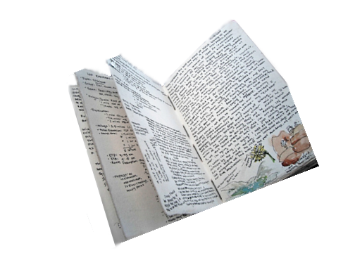
Each session should end by asking learners to record their ideas and reflections. These can be as simple as asking the learners to write down two or three things they gained from the lesson. Ask learners:

- What was new or surprising to you?
- What have you changed your mind about?
- What are you still unsure about?
- What interested you the most, and what would you like to study in more detail?
- What new behaviors will you try based on this class?
- What topics from the class do you want to talk with others about outside of the class?

Evaluating Competence on Learning Objectives
At the end of each module, learners should rate their ability to understand, apply and evaluate/create each of the module’s learning objectives. For example, the “Systems Thinking” module includes the following student self-evaluation for Competency #3.

Student Self-Evaluation
Students self-assess their mastery of the learning objectives in each module along a continuum from understanding from to being able to apply to being able to evaluate and create. An example from the “Systems Thinking” module is shown below:

Competency #3: Partner with One Health team members to develop solutions to complex One Health problems using systems thinking and tools.  How would you rate your ability to contribute as a One Health team member to develop solutions to One Health Problems by: | Understand | Apply | Evaluate/  Create
- Using concepts from “wicked” (complex) problem/ “super wicked” problem theory to better understand how to formulate and approach One Health problems.
- Integrating information and actions across disciplines and sectors using systems thinking tools.
- Identifying leverage points for maximum impact.

- Determining and mitigating potential unintended consequences of planned interventions.
- Creating essential feedback and feed-forward loops.

Grading Rubric
When formally evaluating students, clear expectations should be set before the lesson on how their work will be evaluated and how grades/points will be assigned. A grading rubric is a tool that provides clear descriptions of the characteristics of the work associated with each component of a course at varying levels of mastery. As such, rubrics make explicit the implicit criteria by which a student’s performance is graded or assessed.

For students, using a grading rubric provides:

- Clear expectations and criteria for grades at the beginning of the course.
- A mechanism to monitor and assess their performance as they work toward clearly indicated goals.

For One Health instructors/facilitators, a grading rubric provides:

- Consistent standards from students to student.
- Consistent standards from instructor to instructor.

A grading rubric generally is composed of three parts:

- Criteria – Specific qualities to be assessed.
- Standards for levels of performance – Generally represented by a matrix, competency is represented by at least two levels but often three or even more. Each level articulates the extent of the student’s competency with fulfilling the criteria. Levels are progressive and often cumulative in nature.
- Assigned value for each level – Contains a numeric or grade assignment of each level that corresponds with how well the student has mastered the instructional objective.

An example rubric for grading collaboration on a team project might be:

Criteria | Excellent | Acceptable | Unacceptable
Teamwork | Team worked well together demonstrating a high level of mutual respect and collaboration to complete a high quality product. | Team worked well together most of the time with a few occasions of communication breakdown or failure to collaborate when necessary. Final product was adequate. | Team did not collaborate or communicate well. Team members worked more independently, resulting in a fragmented product.

For more examples of grading rubrics, go to:

- Carnegie Mellon University at www.cmu.edu/teaching/assessment
- Association of American Colleges and Universities at www.aacu.org/value/rubrics
- Rubistar, an online tool at rubistar.4teachers.org

RESOURCES IN THE ONE HEALTH MODULES

Each One Health module has:
- A Facilitator Guide
- PowerPoint presentation slides
- A Student Guide
- Copies of selected references and resources that are open source
The Facilitator Guide, in addition to providing step-by-step instructions on how to facilitate each session, contains in-depth material about the topic including:

   | - Facilitator Background Resources – Definitive textbooks and articles in the field that the instructor/facilitator can use to learn more about the subject
 | - Facilitator Quick Notes – Background information for the instructor/facilitator on topics that the learners are independently researching and presenting
 | - References for students – Additional resources for learners including articles, websites, online materials
Reference materials that are available with the modules are listed under “References in this Guide.” This can be found on the module “Resource” folder. References under “Additional References” are either available free online or available online for purchase.

PowerPoint presentations have been prepared for each of the modules. These presentations include presentation materials, instructions for activities, questions for debriefing activities and video clips. Links to the video clips are embedded in the slides. Clicking on the icon of the camera will advance to the video.

The materials have been designed to be printed double-sided and left-hand bound.

All the materials are available at:
http://seaohunonehealth.wordpress.com/.

SETTING UP THE CLASSROOM

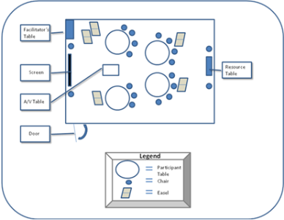
The ideal classroom setting is to have participants seated in small work groups able to comfortably see the projection screen or white board. This arrangement makes participants feel equal and facilitates, not only small group dialog, but large group discussions. It is recommended that the instructor/facilitator rotate table assignments periodically to ensure that participants are able to interact with and learn from a variety of their learning colleagues.
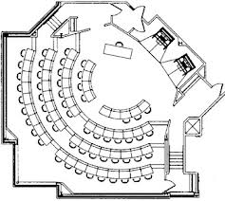
Often, the class may be in an auditorium. In this setting, if you are facilitating a small group exercise, you can have students in one row turn around and work with students in the row behind them. Or you can have the groups find a place to work near the classroom. If students chose to work outside of the classroom, be sure to give them a specific time to return.

Other classroom configurations include:
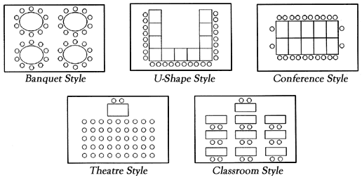
The key is to be flexible and find a way to make the classroom configuration work for the activity you are facilitating.
- For large group activities, it is important that everyone can see and hear the presentation if you are facilitating a presentation; if you are facilitating a large group discussion, you need to make sure students in the back of the room can hear students sitting in front of them.
- For small group activities, it is important to be aware of the noise level in the room so that group members can hear each other.
- For individual activities, make sure the room is quiet and people have a bit of privacy.

COMMENTS AND SUGGESTIONS

The One Health Course is a living document. We welcome your feedback. Send your comments, suggestions and additions to:
Roberta Talmage
TRG, Inc.
4401 Wilson Blvd., Suite 200
Arlington, VA 22203, USA
001-703-875-8909
rtalmage@trg-inc.com

